

DXC RealTime Projects

AZ-900, DP - 203



June 10, 2022

dxc technology PVT. LTD

Name: Sai Kiran Anche

Reg No: DXC262AB12021

**Project1 Name: Smart Vehicles**

Date: June 10,2022

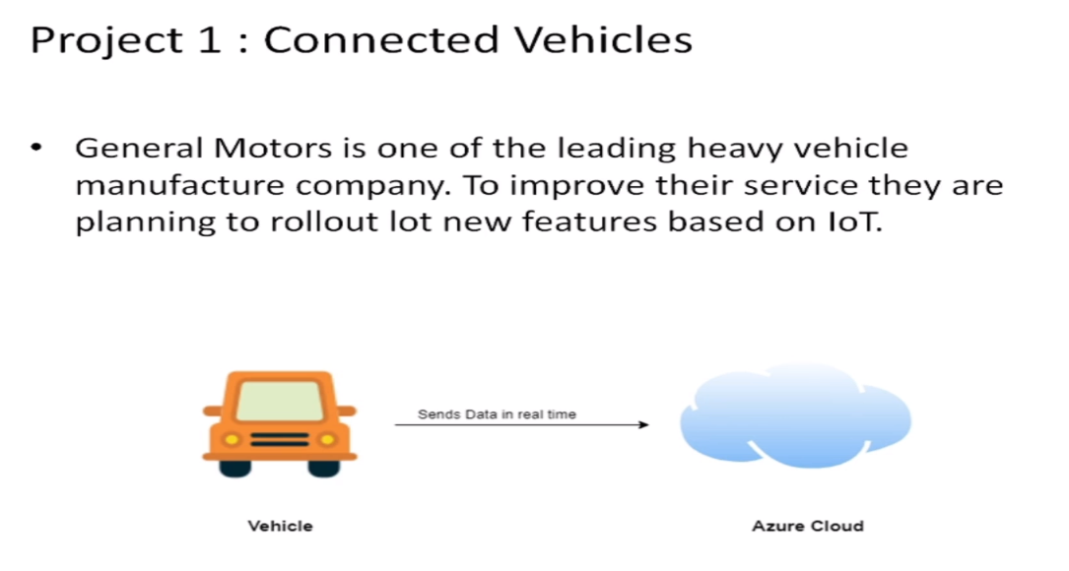

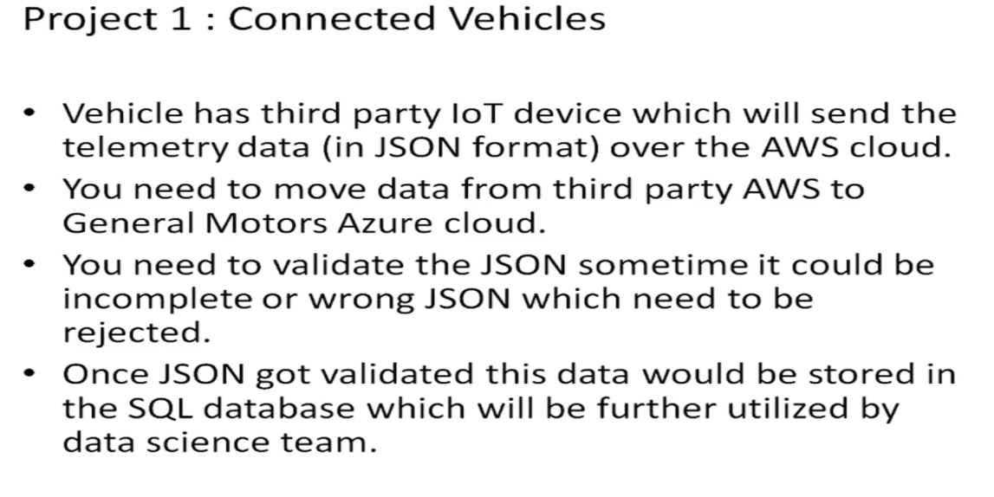

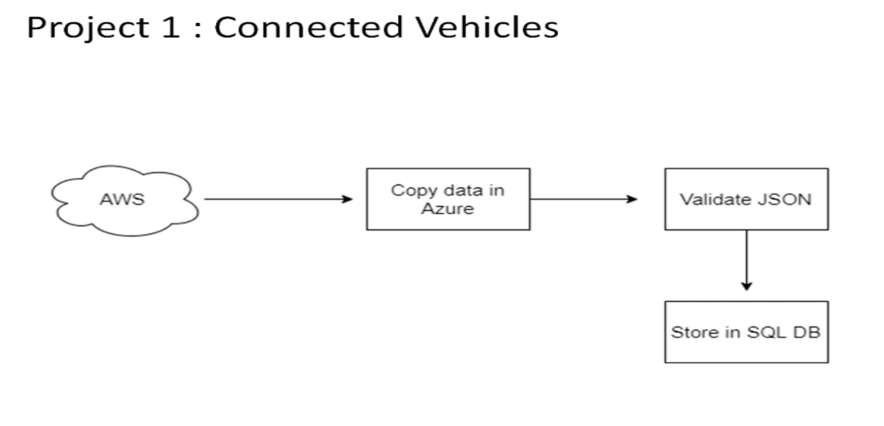

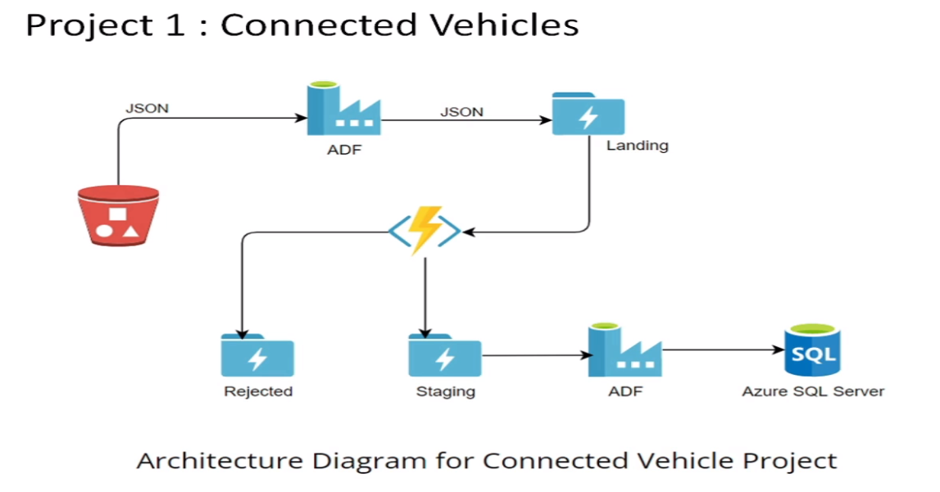

Practical Lab: Create **Azure Data Factory** Account For Data pipelines

Step1: Goto the URL: <https://portal.azure.com/#home> and search AzureDataFactory in the search bar.

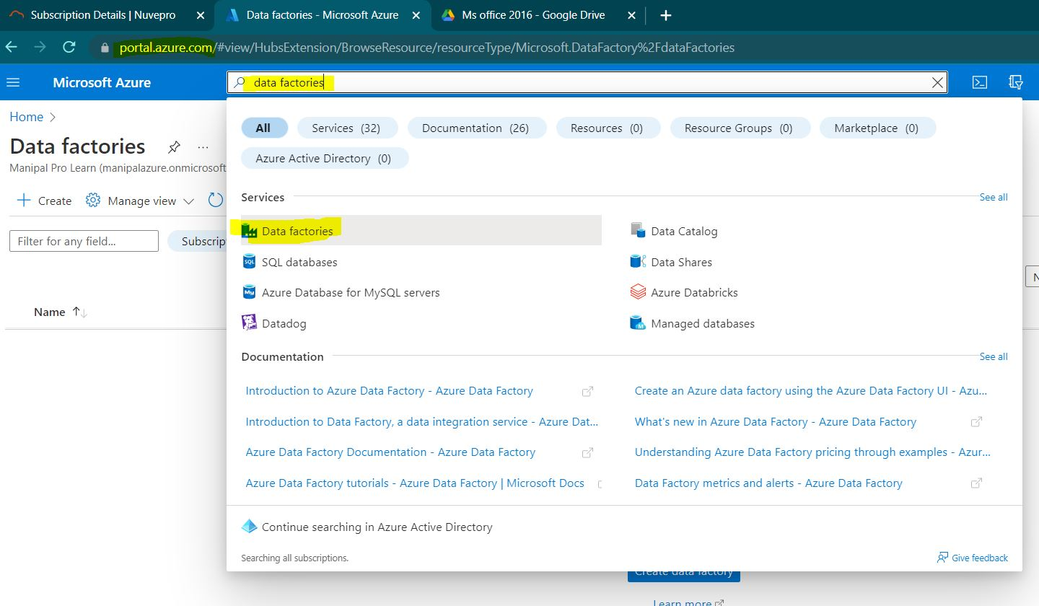

Step2: click on the craeate button.

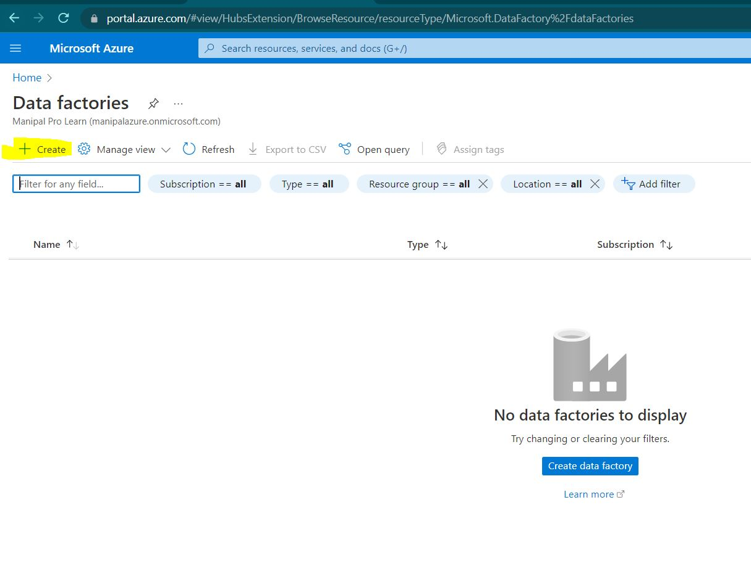

Step3: Create a new resource group for the GM motors DF.

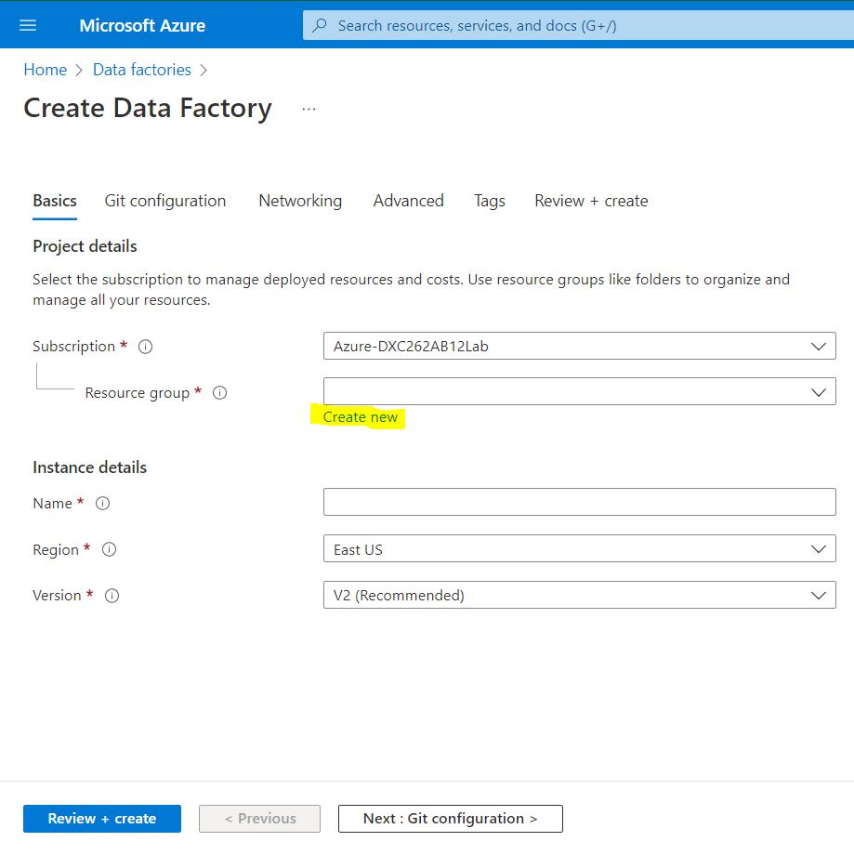

Step4: name the data factory and click on git configuration.

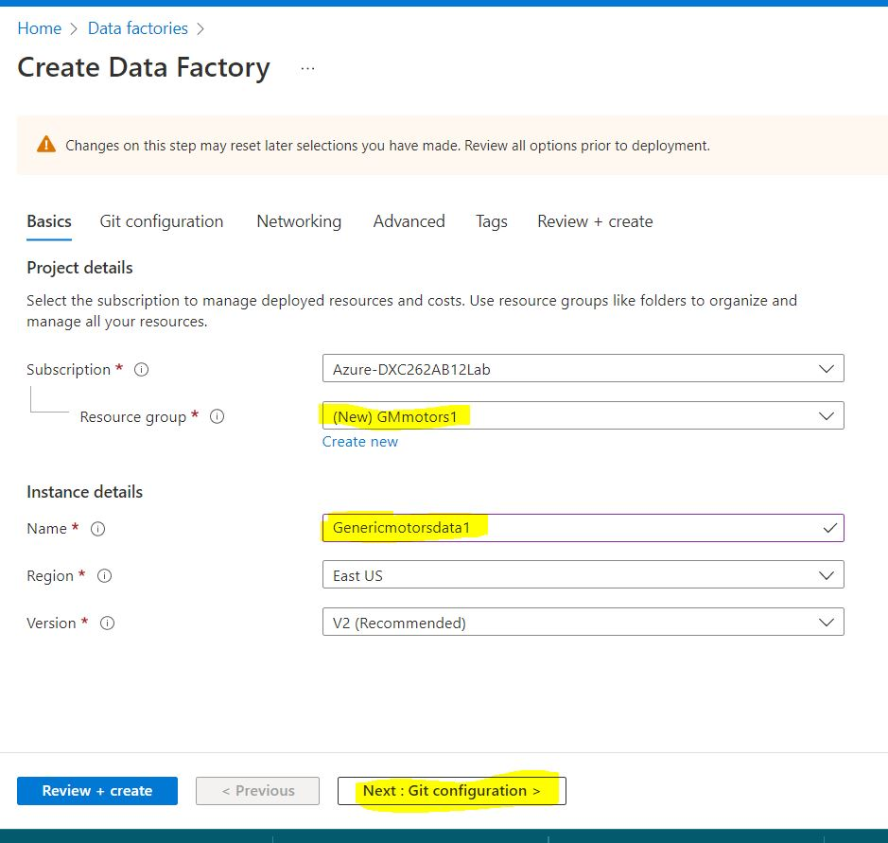

Step5: click on configure git later and review +create.

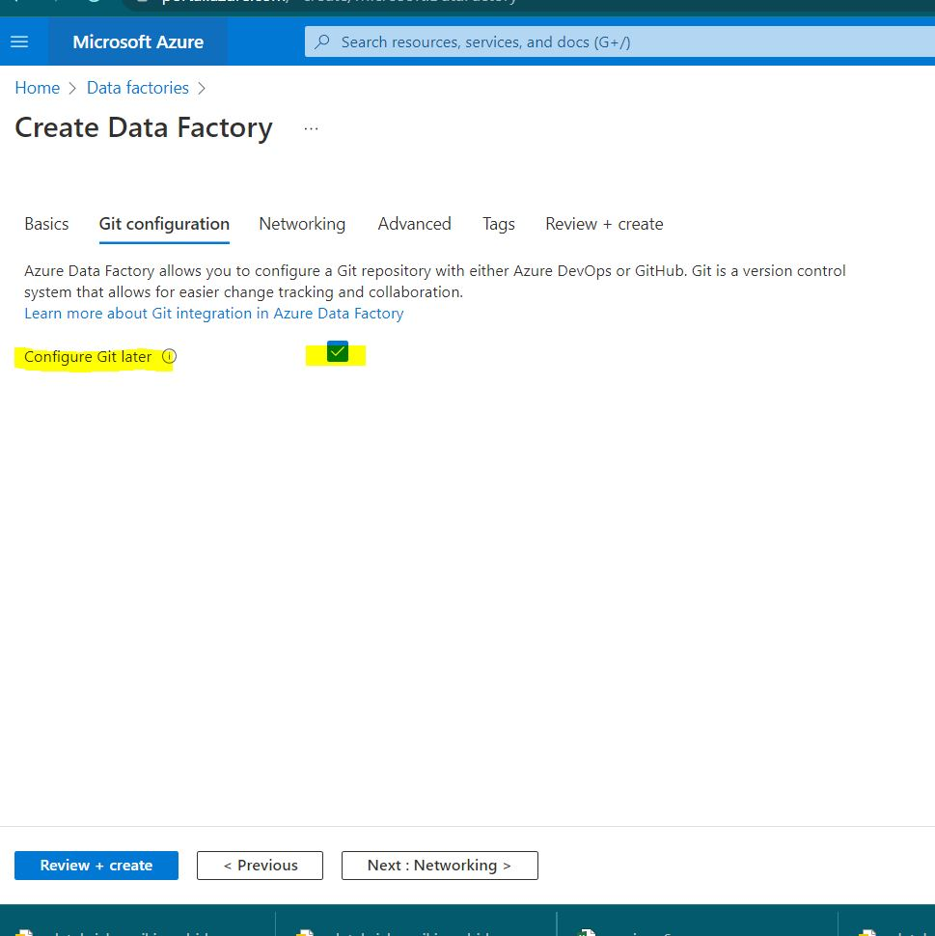

Step6: after successful validation click on create.

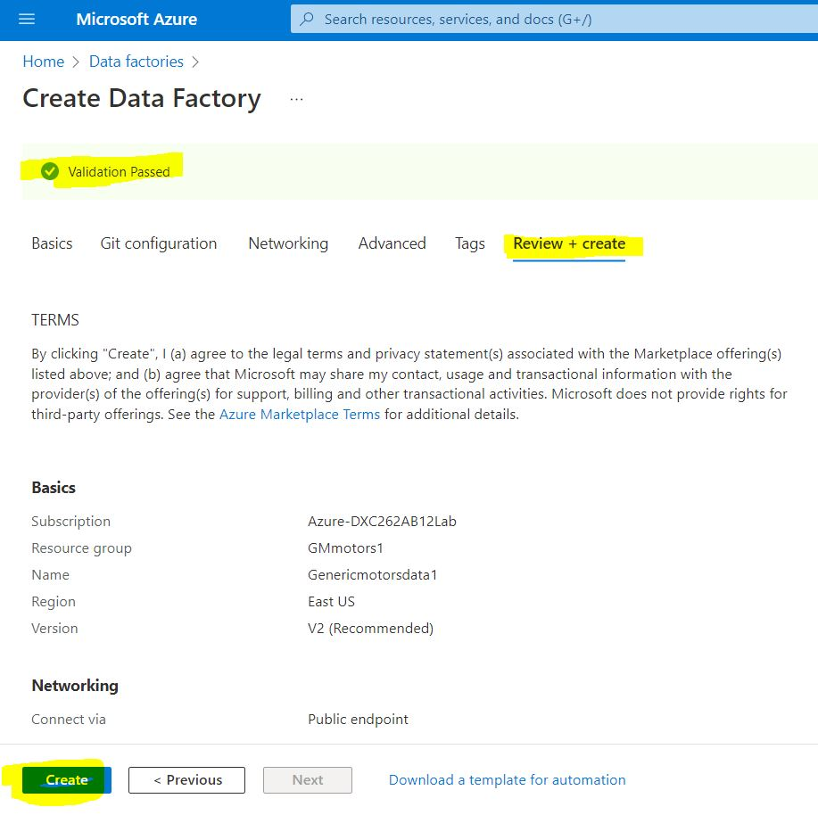

Step7: The Data Factory is created.

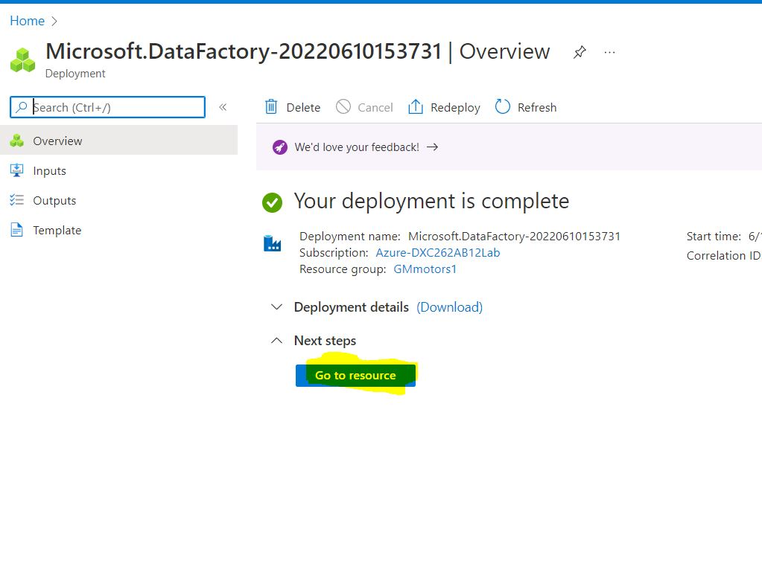

Practical Lab: Create **ADF Pipeline** End to end pipeline with triggers enabled

Step1:Open the Homepage pf the data Factory.

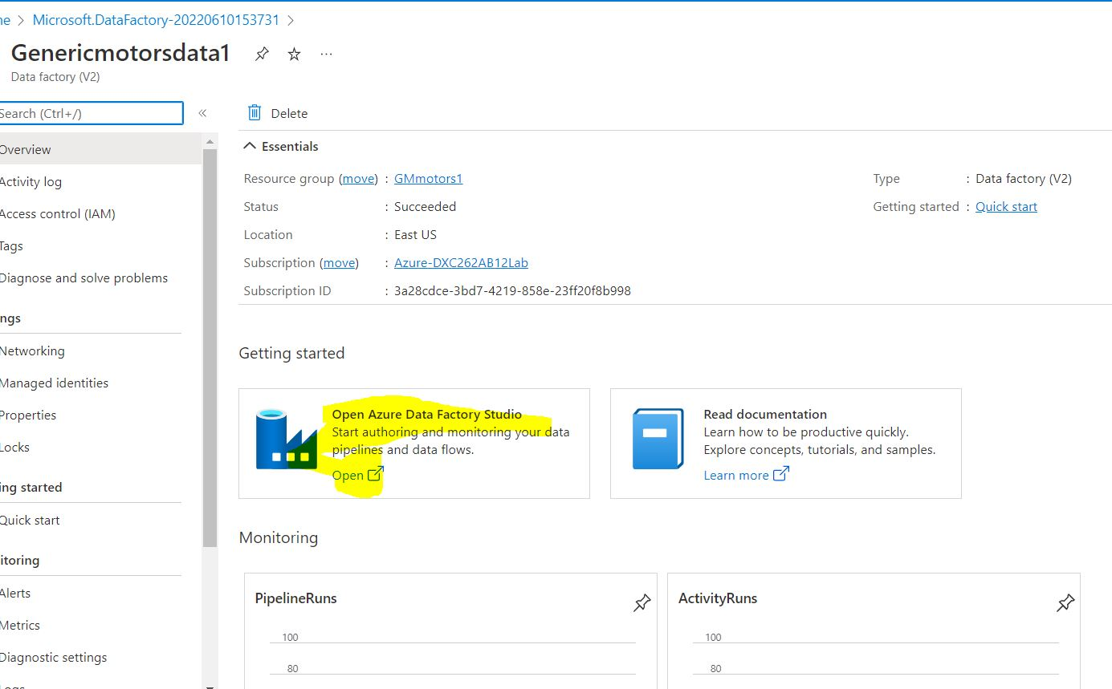

Step2: click on home as we need to create blob storages.

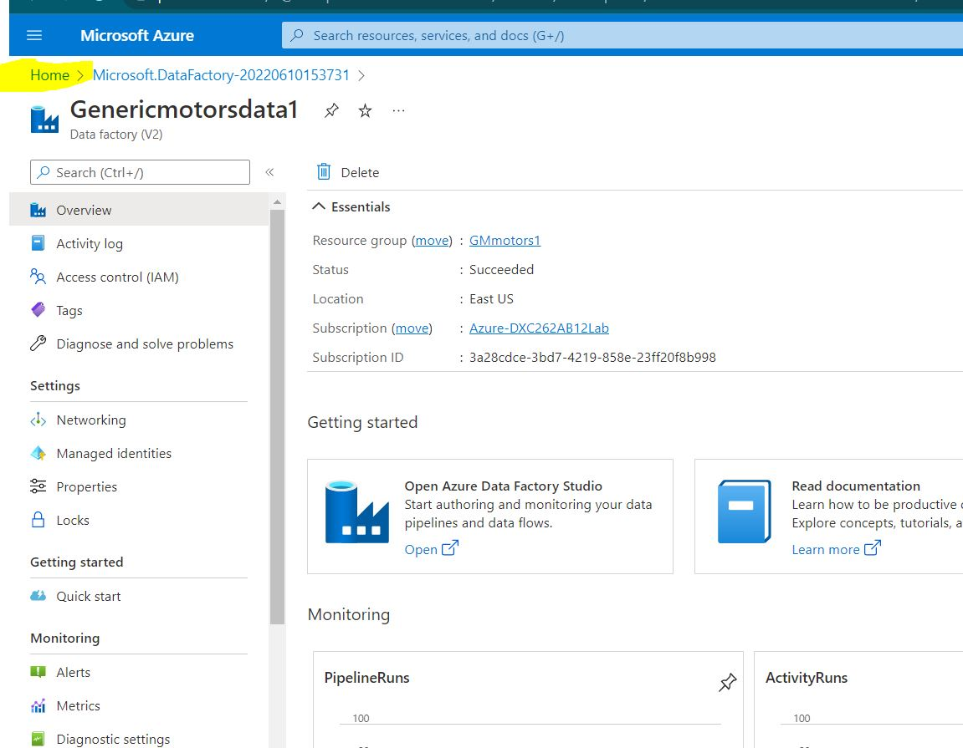

Step3: open storage accounts and click on create

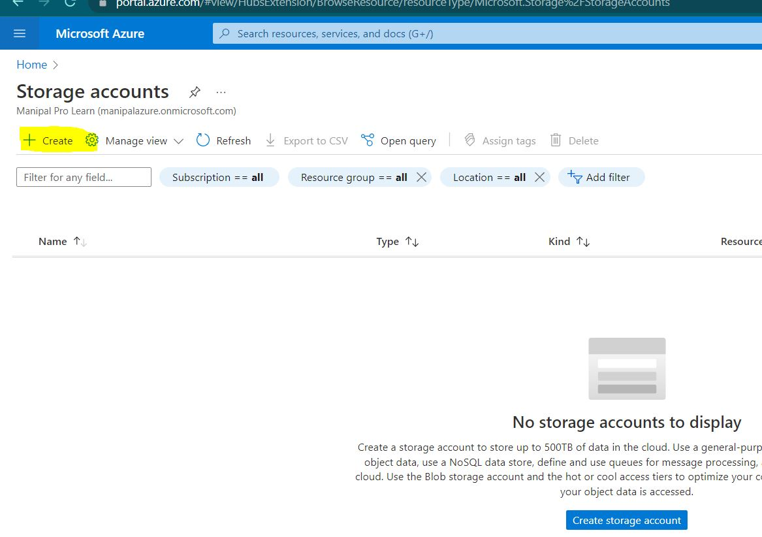

Step4: name the storage account and review it.

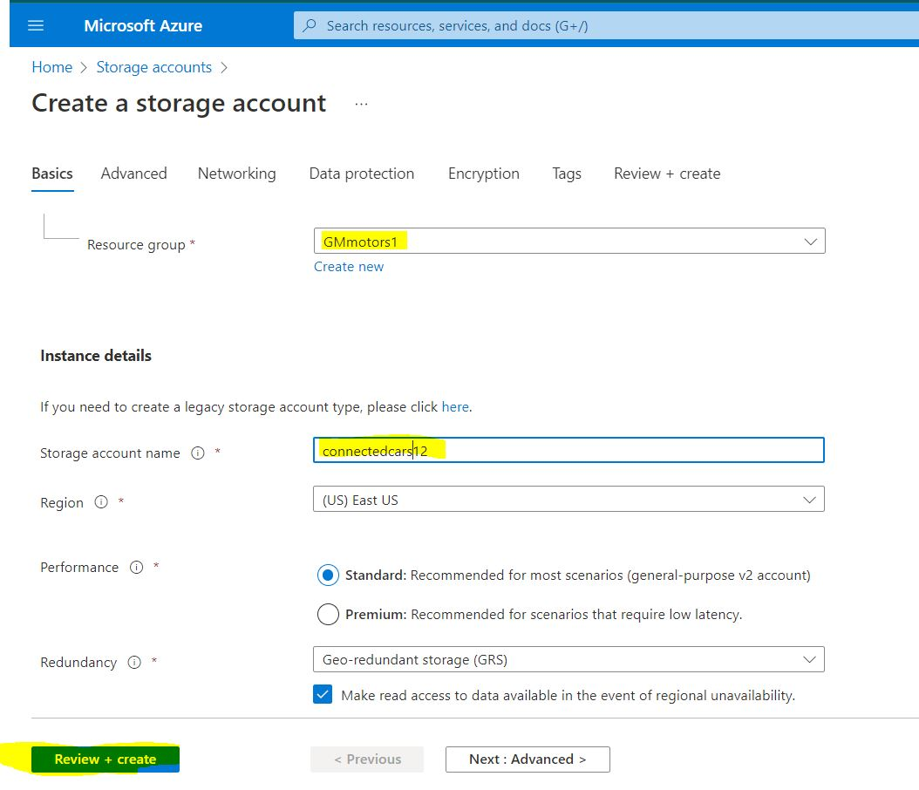

Step5: after successful validation click on create.

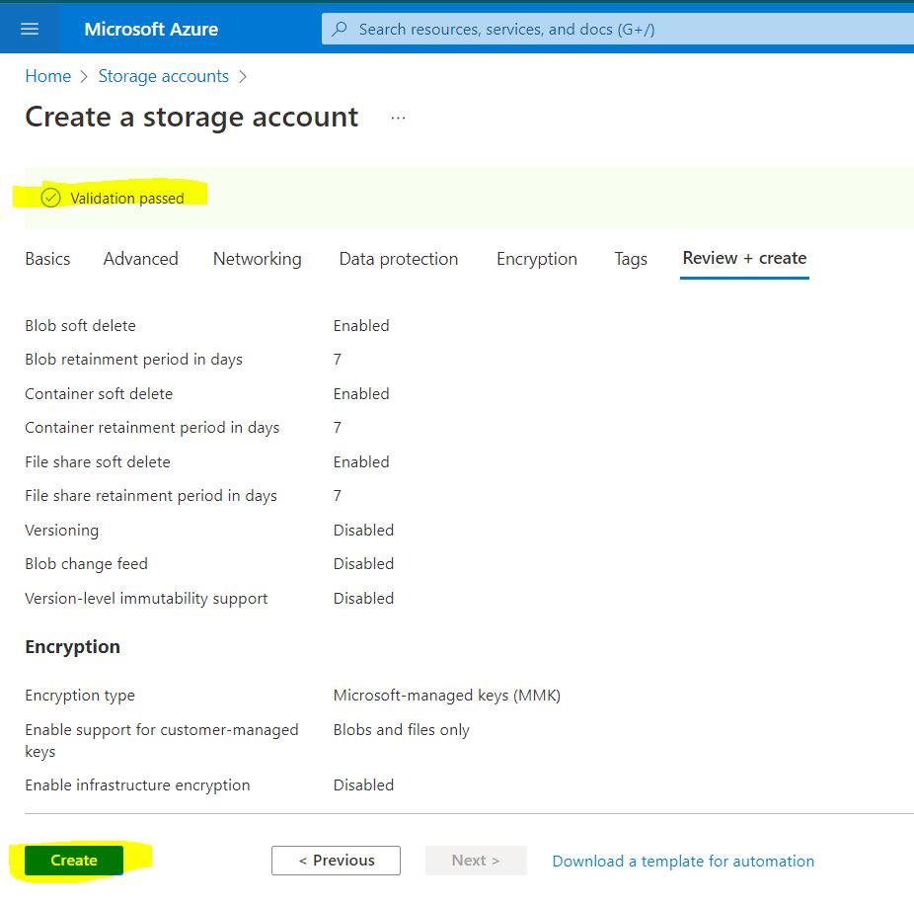

Step6: our storage account creation is done.

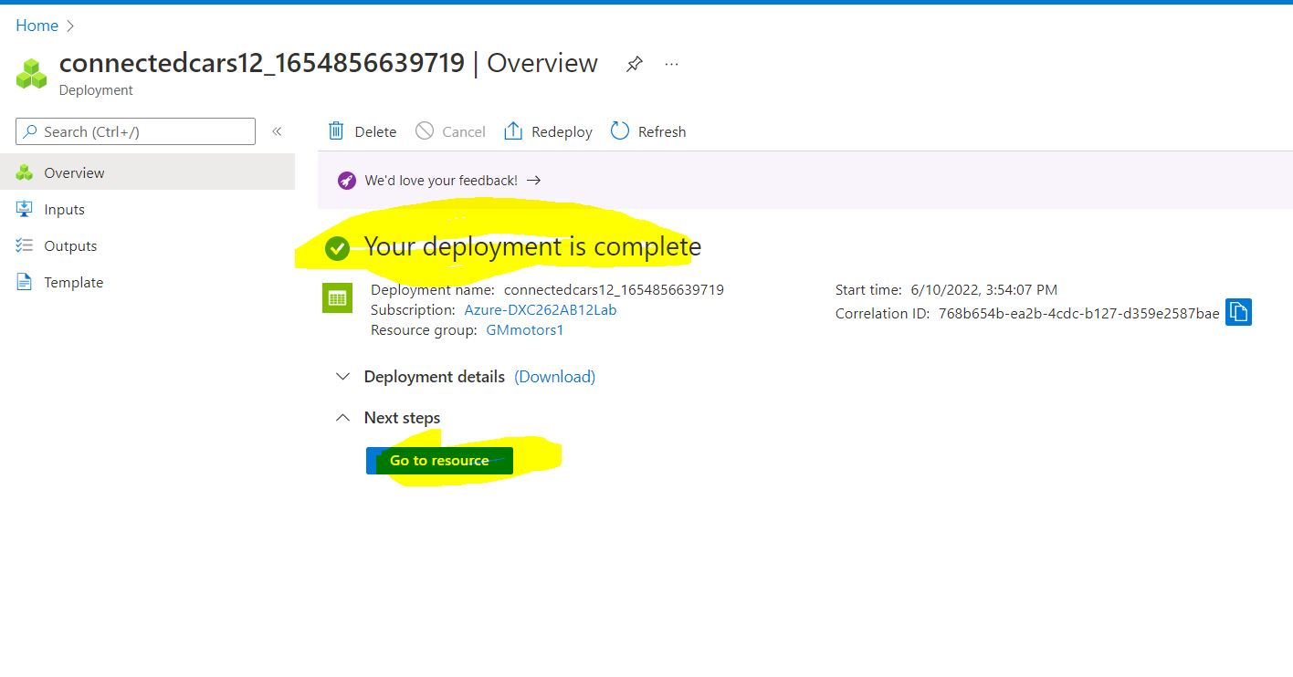

Step7: open storage accounts and click on containers.and create a container.

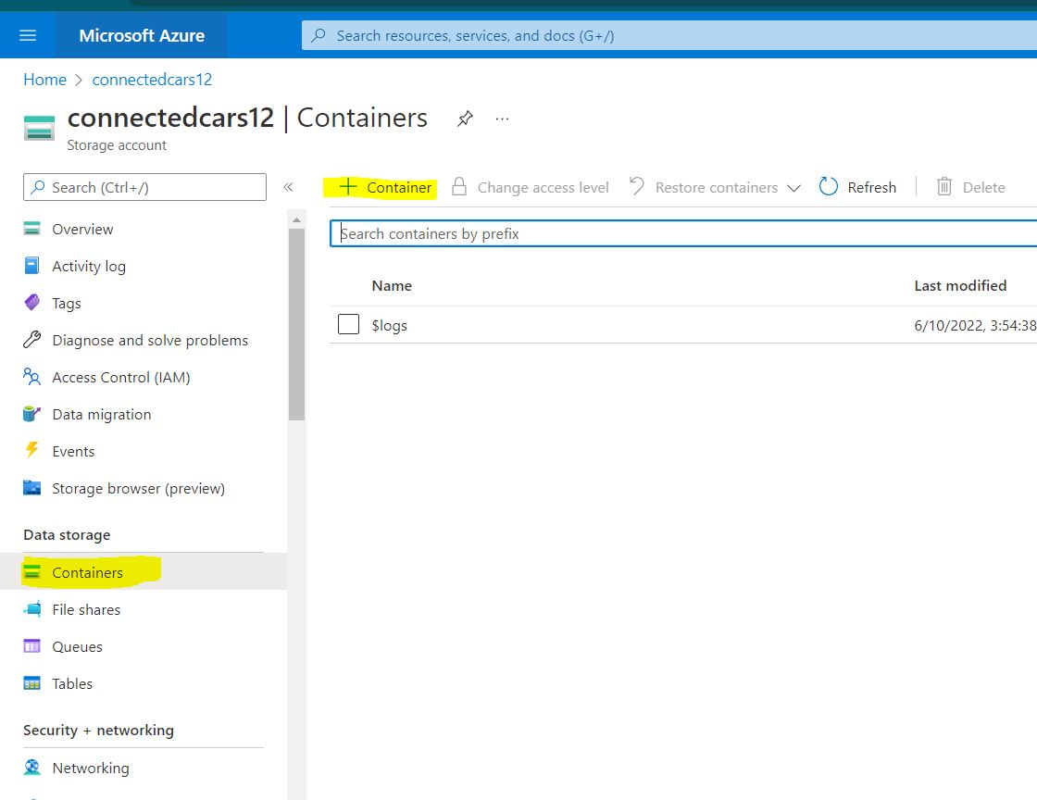

Step8: name the container and give access level as blob.

and then create. It is the source folder.

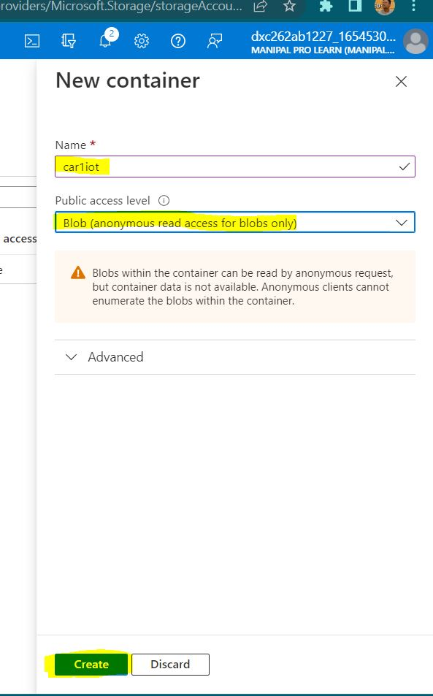

Step9:same way create destination blob too.

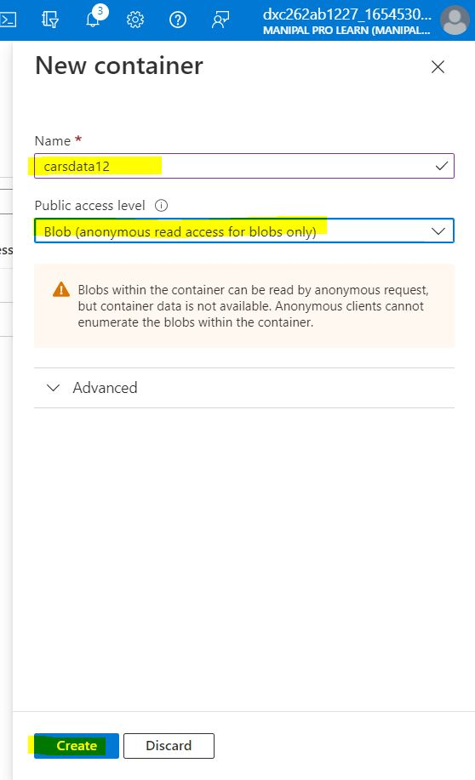

Step10: we can see the blob storages in the given screenshot.

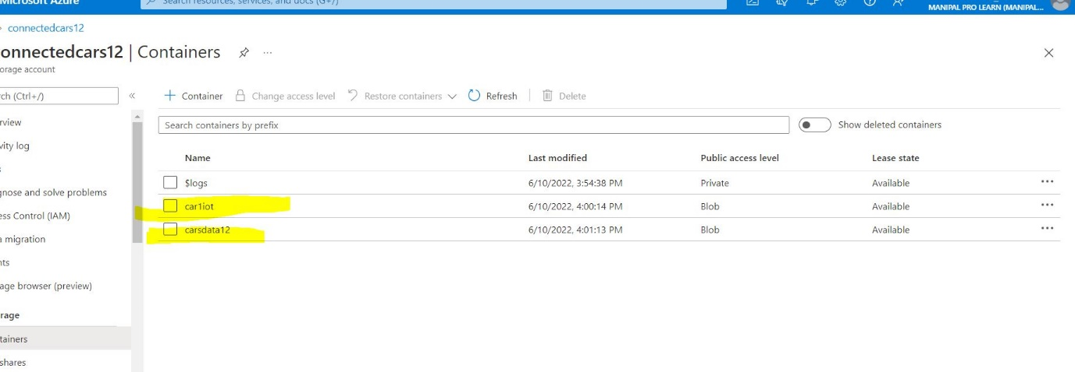

Step11: upload some data into the source blob storage.

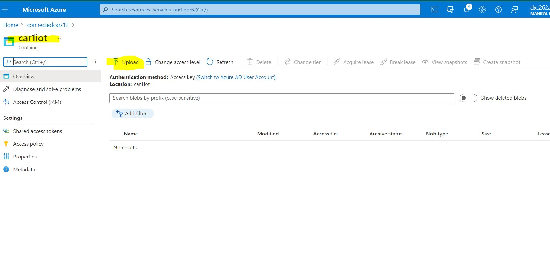

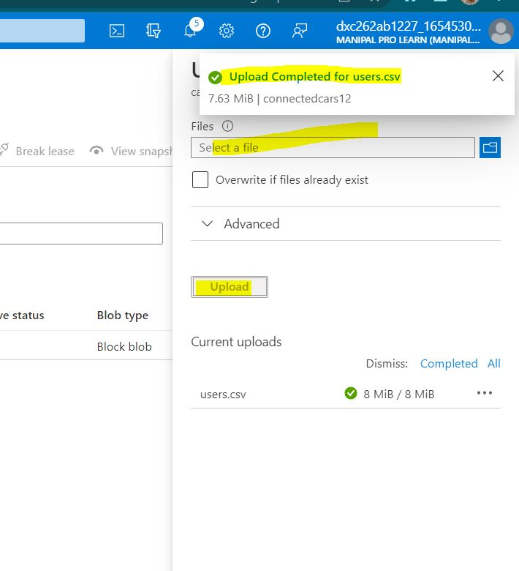

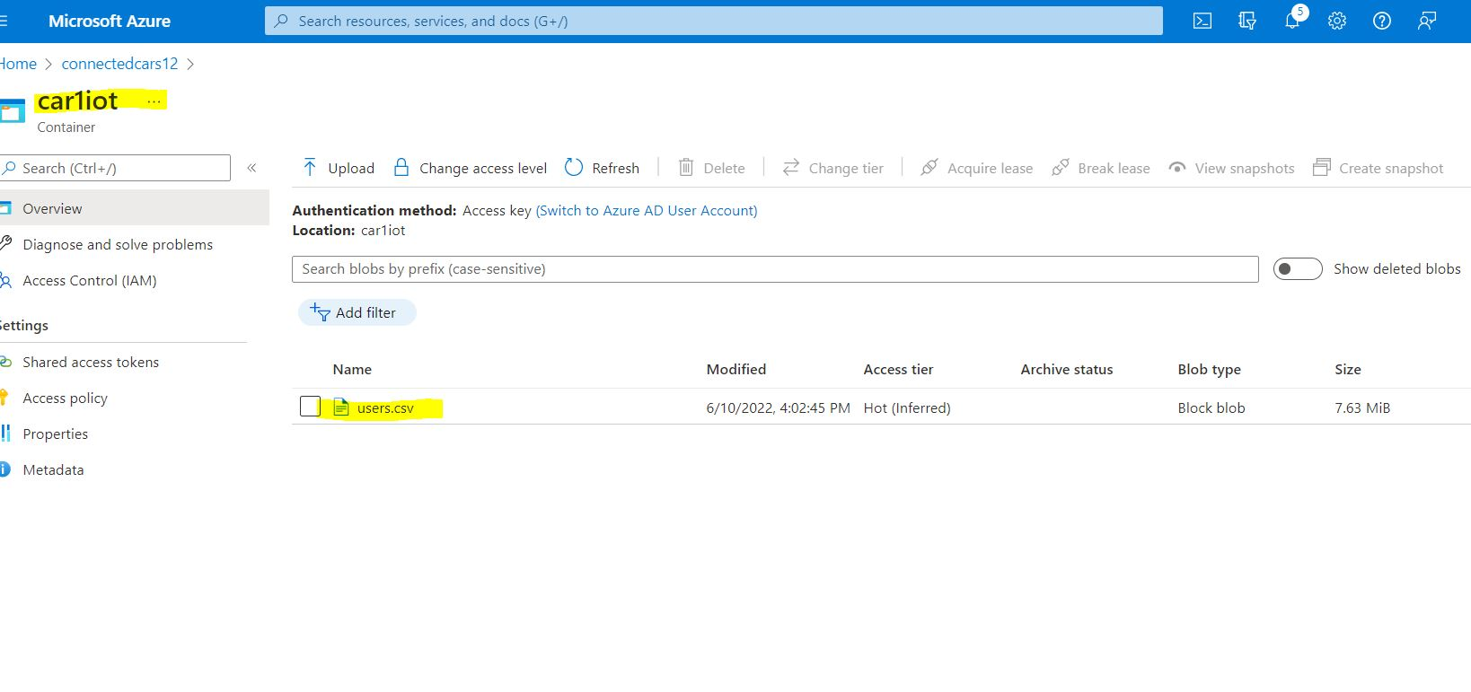

Step12: goto data factory home page and click on injest data.

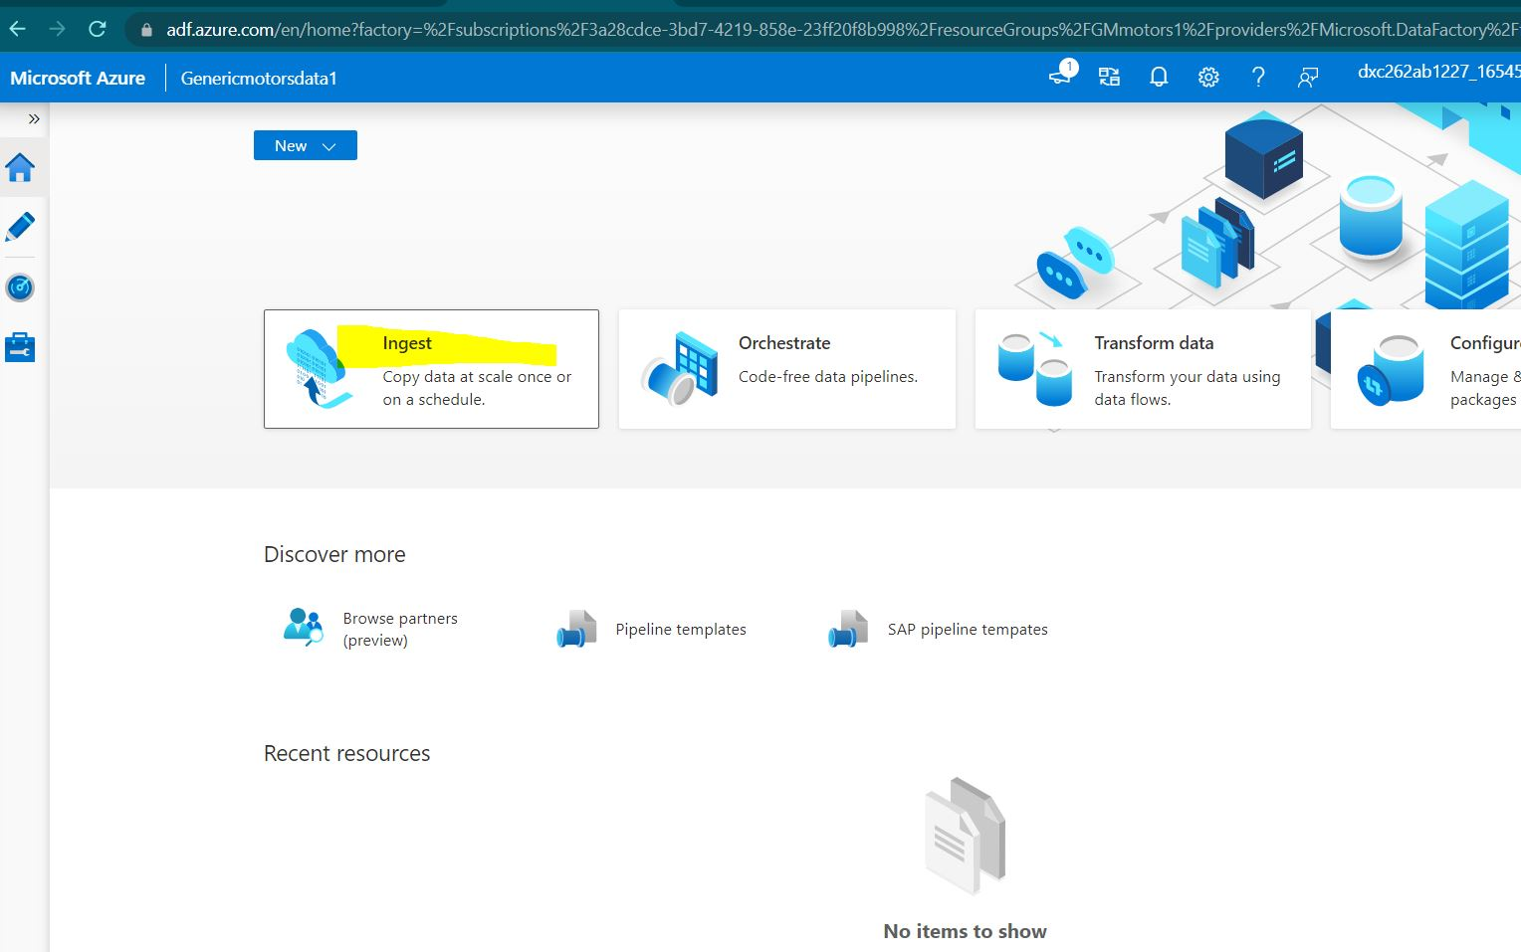

Step13: select Built-in-copy task and run once now. Then click next.

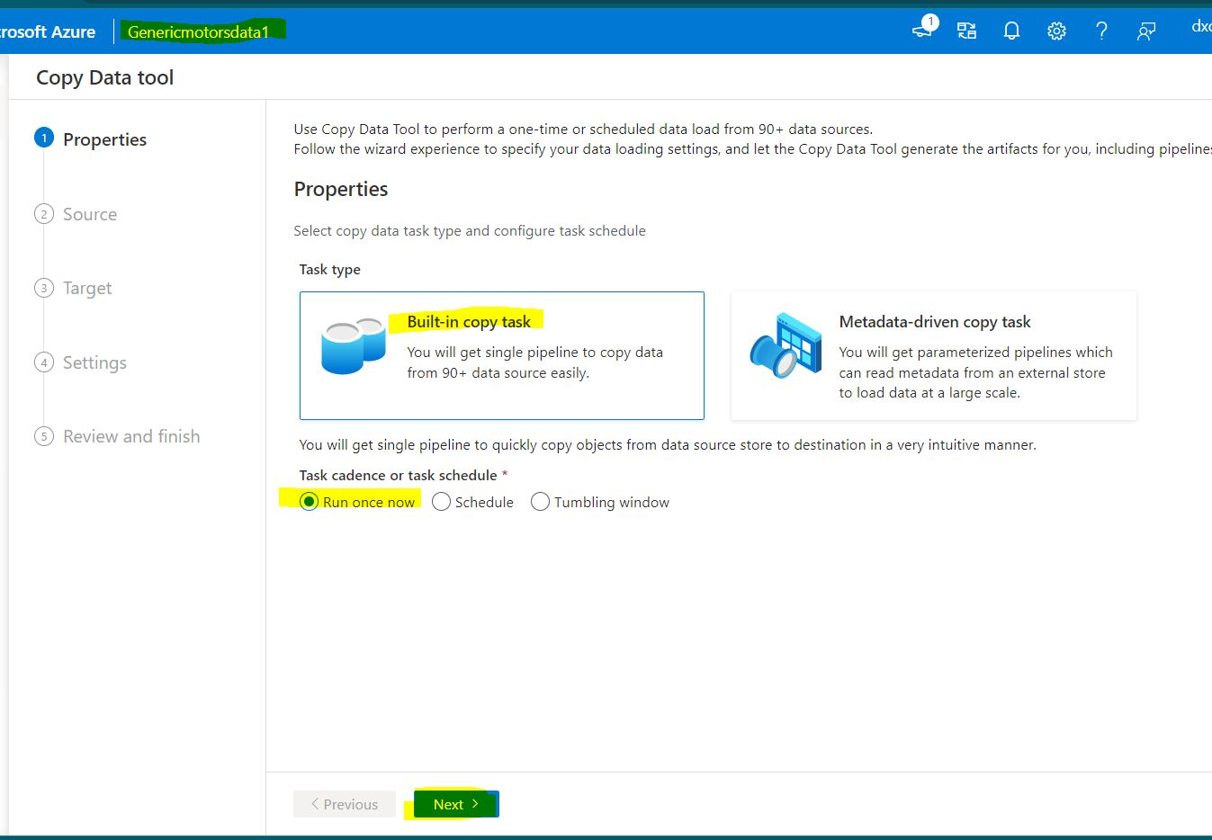

Step14: select source type and click on new connection.

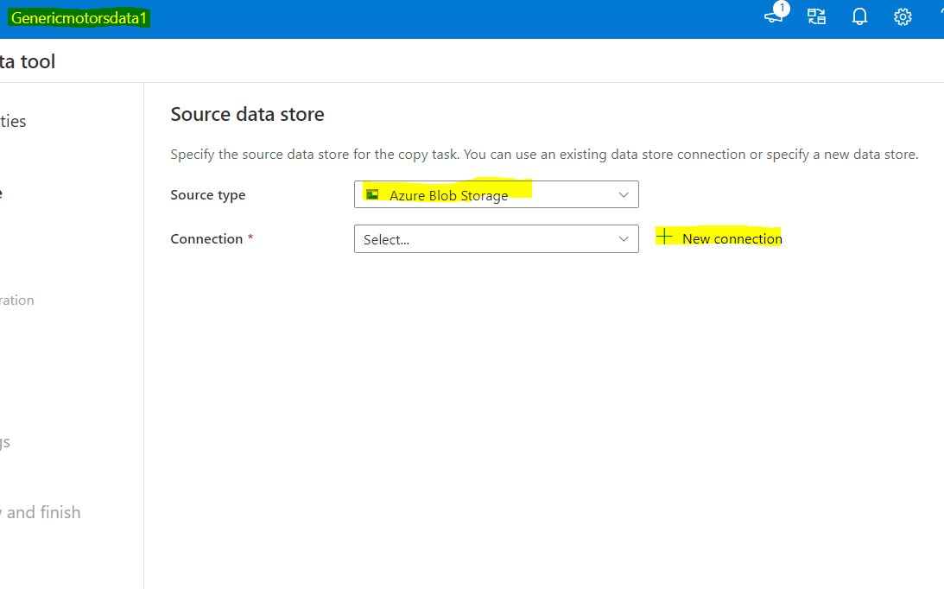

Step15: give the storage account details and test the conection.

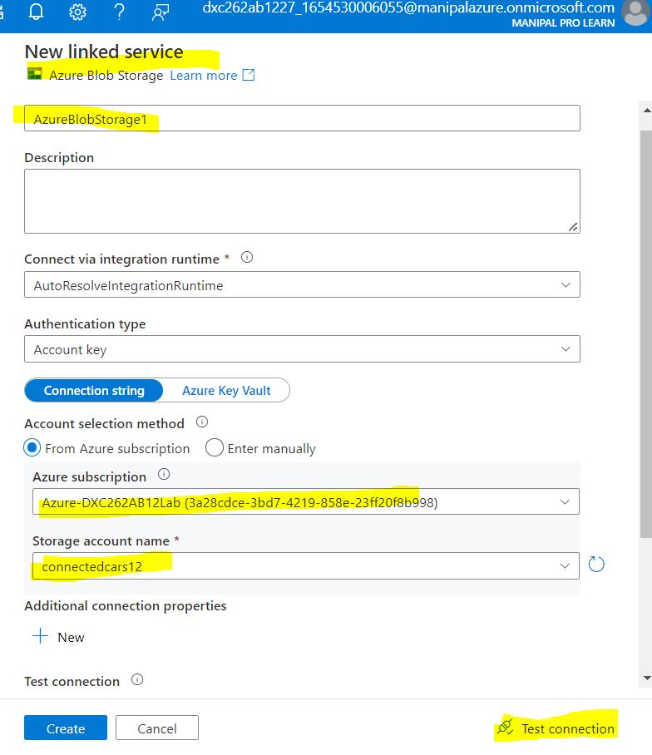

Step16: after the connection is successful click on create.

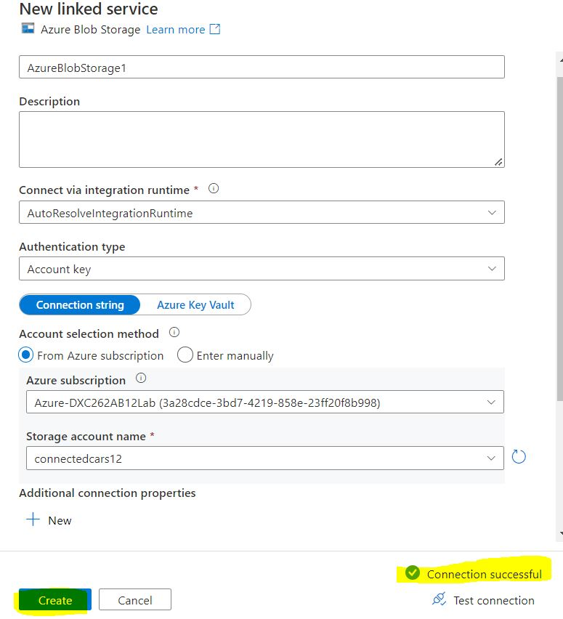

Step17: now select the source folder and click ok

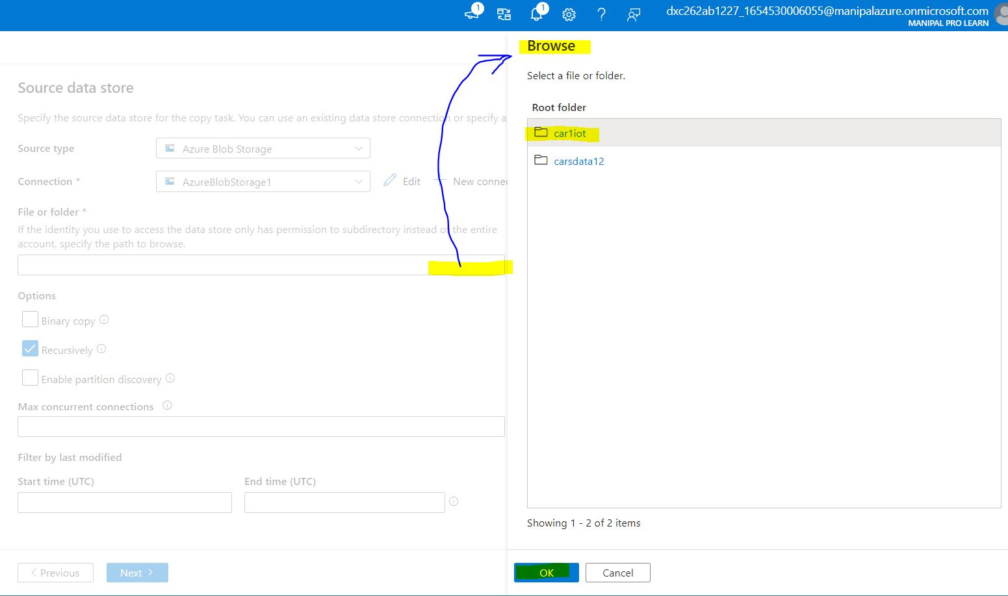

Step18: Then click on Next.

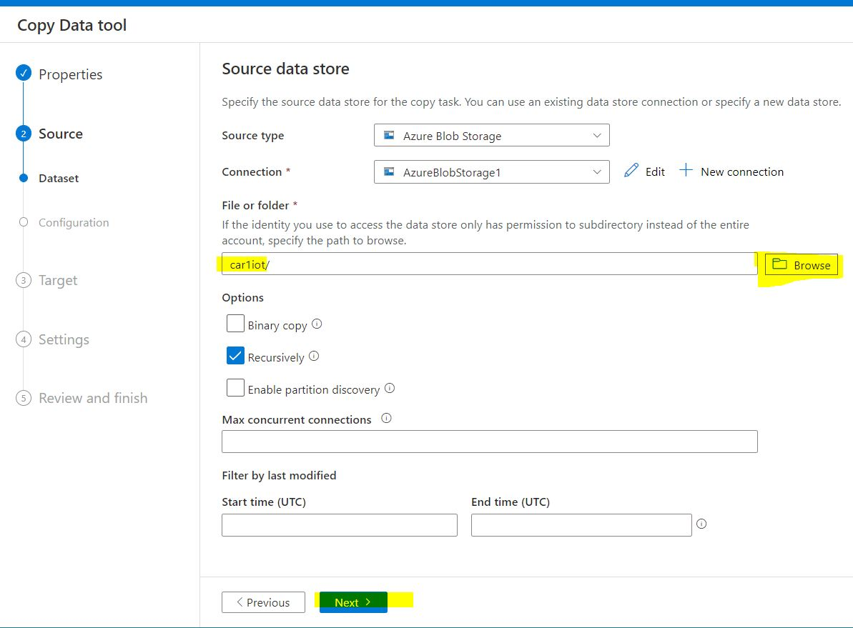

Step19: select the file format and other settings.

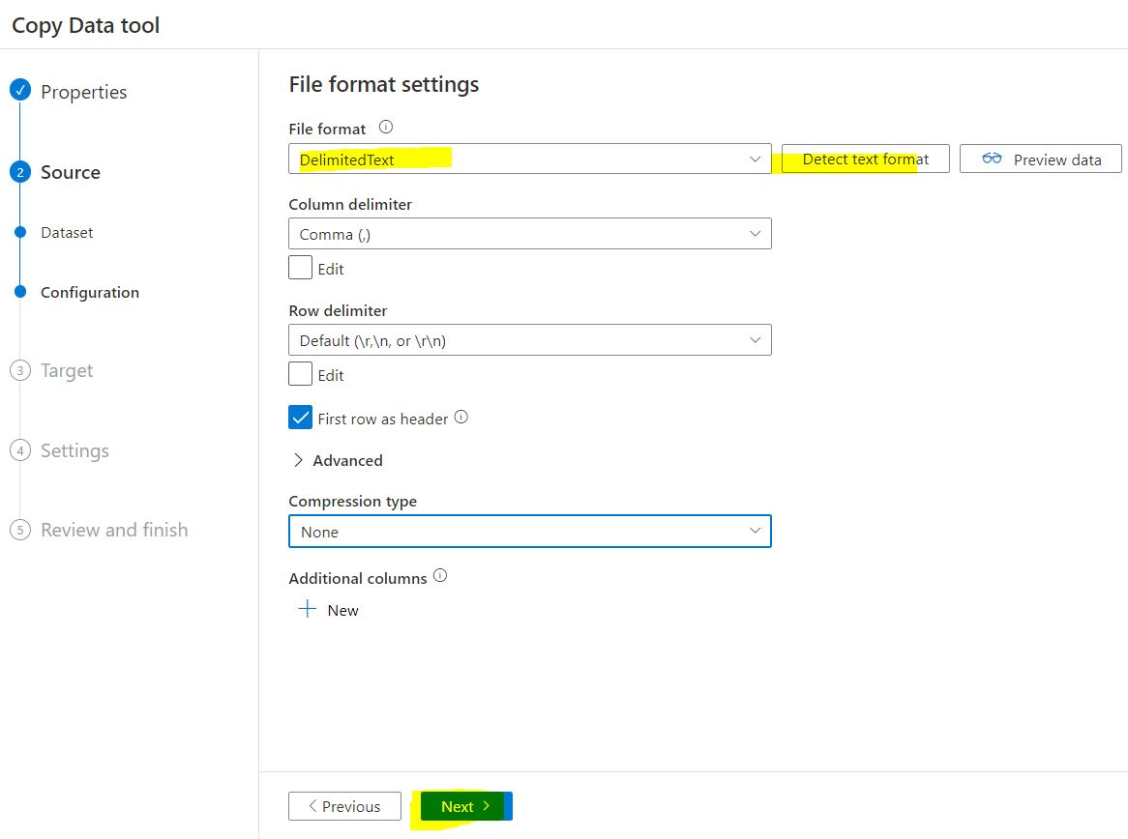

Step20: select the destination settings and update the information.

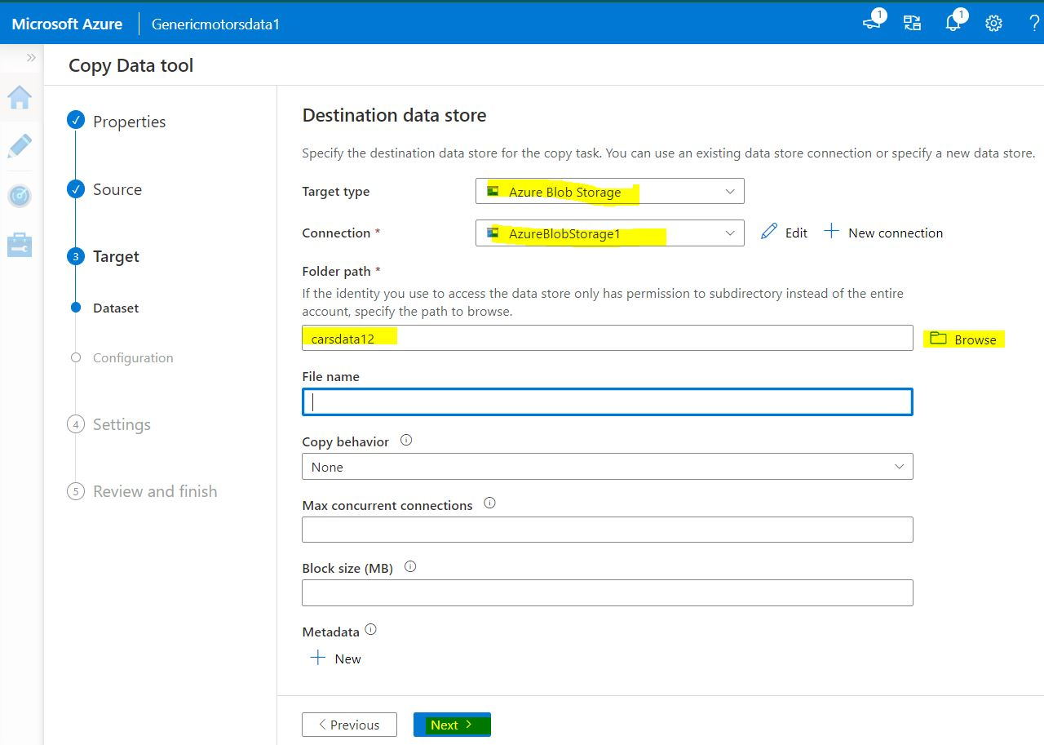

Step21: we can see the summary of the pipeline and click on next

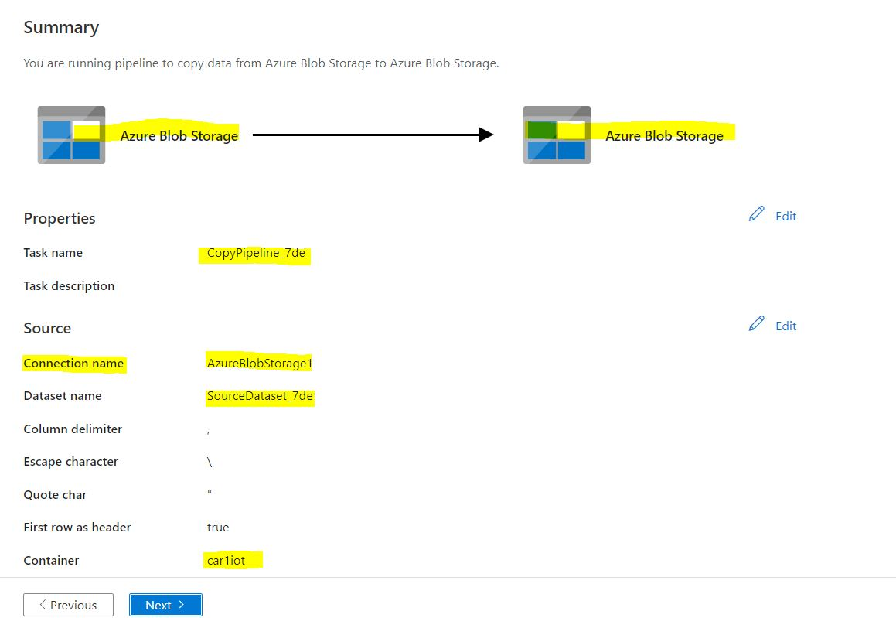

Step22: click on next.

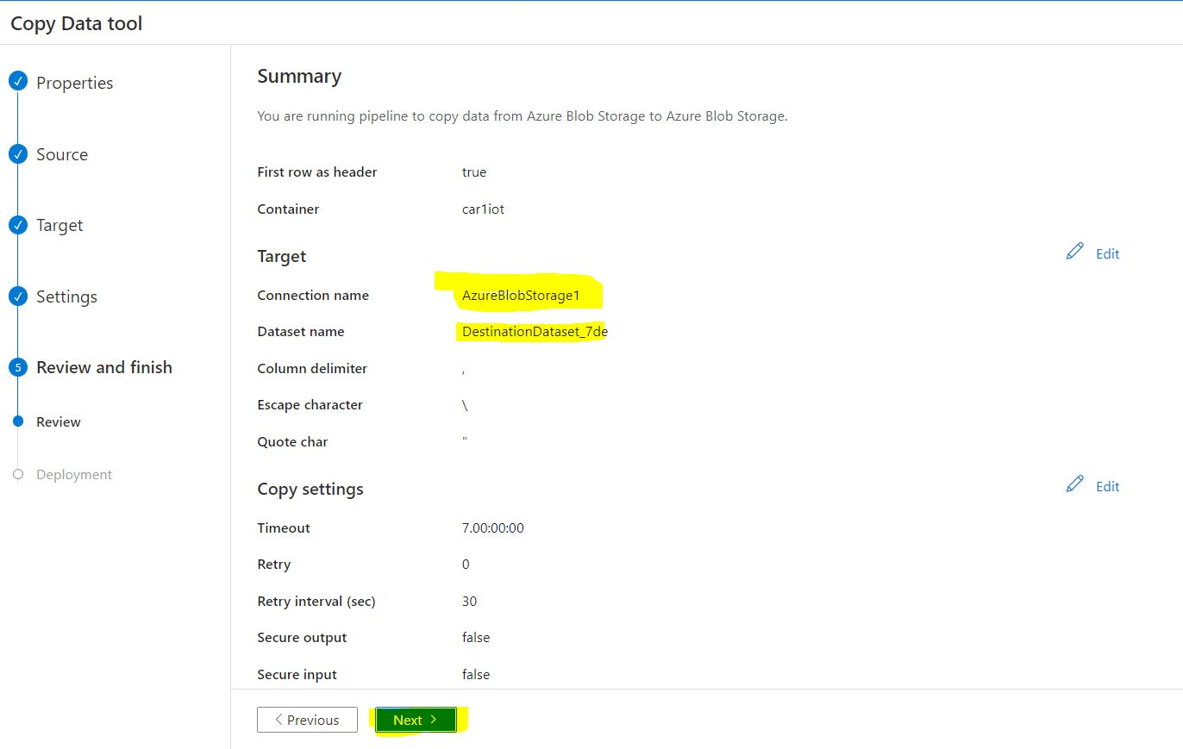

Step23: we can see that the deployment has been completed successfully

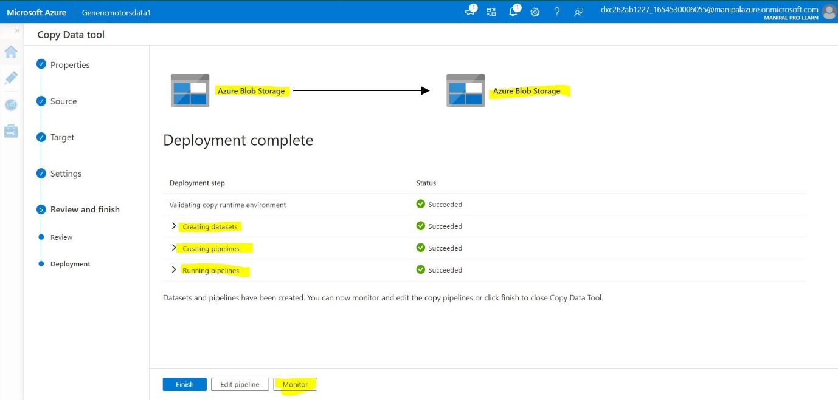

Practical Lab: Create **Azure blob trigger** logic Create Azure **SQL Server and Database**

Step1: got to portal.azure.com and search azure SQL.

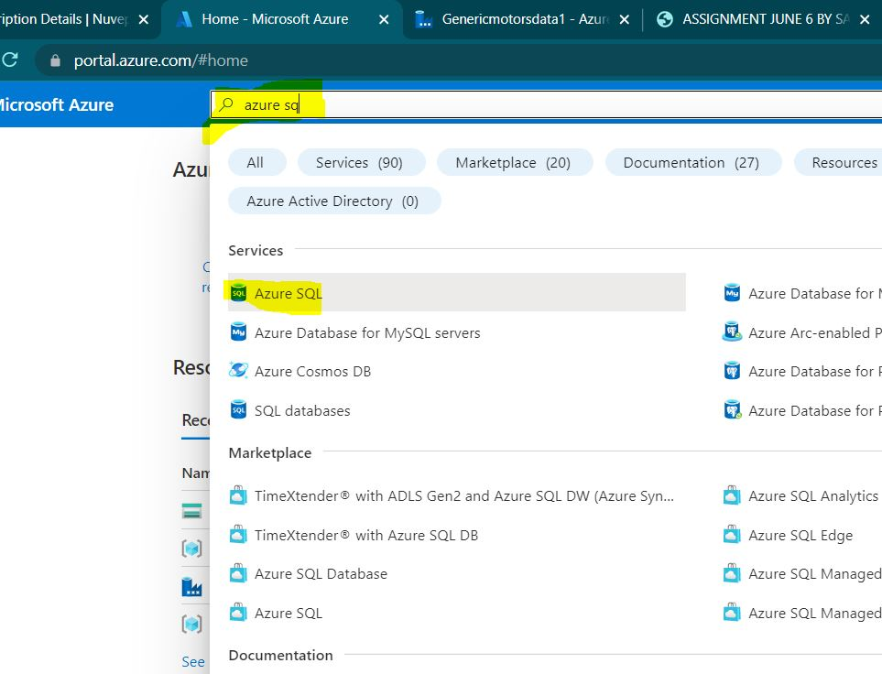

Step2: open the home screen of azure SQL and click on create.

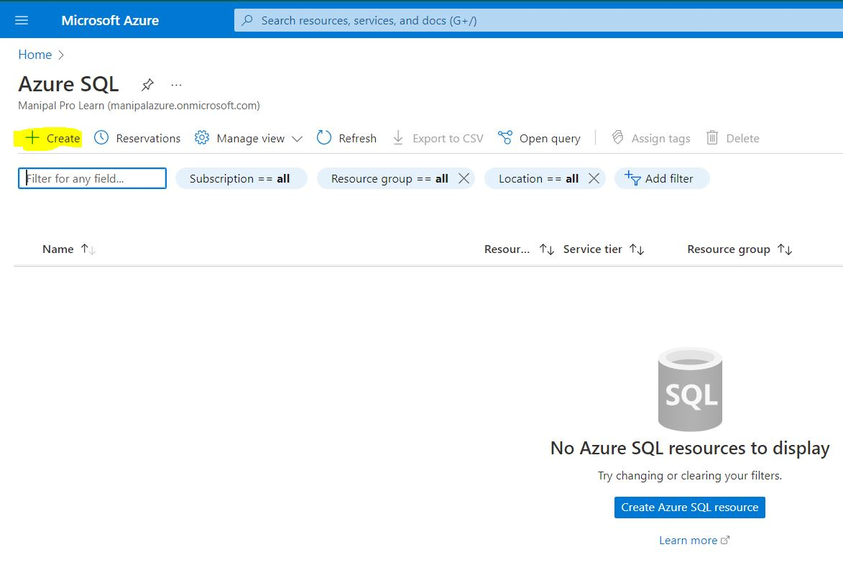

Step3: select SQL databases and click on Create.

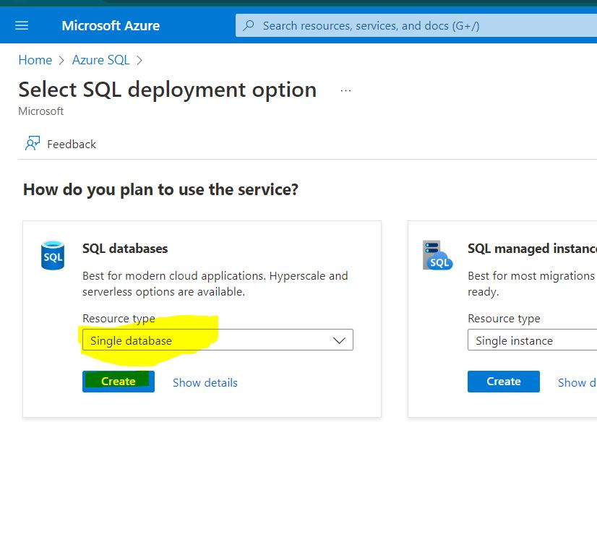

Step4: select the resource group and give name to the data base.

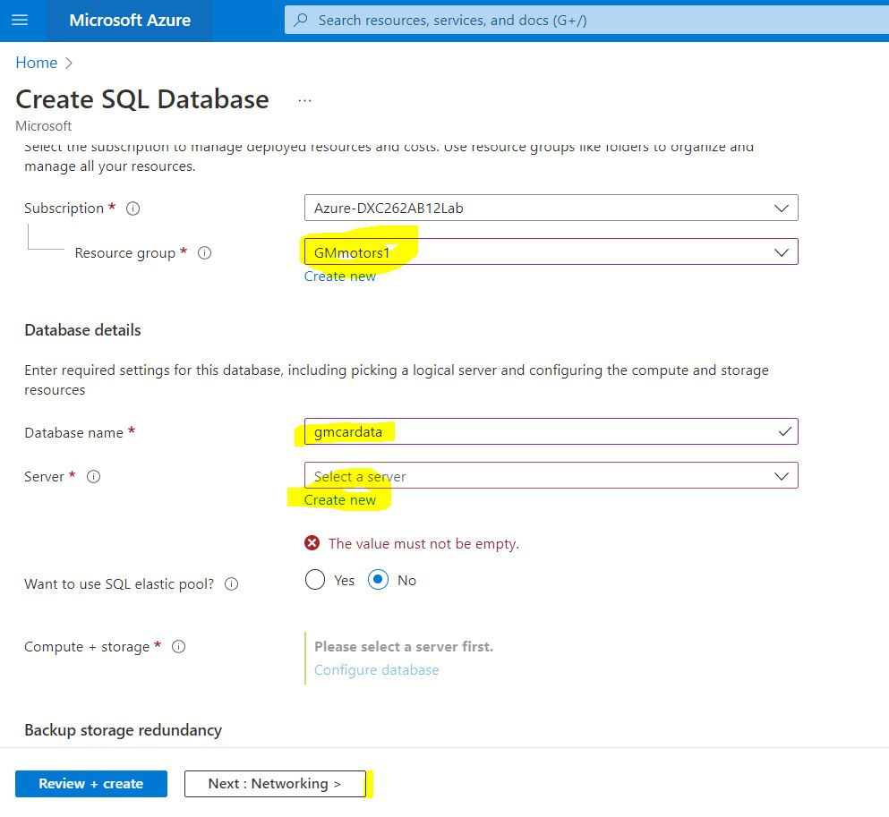

Step5: Click on Networking

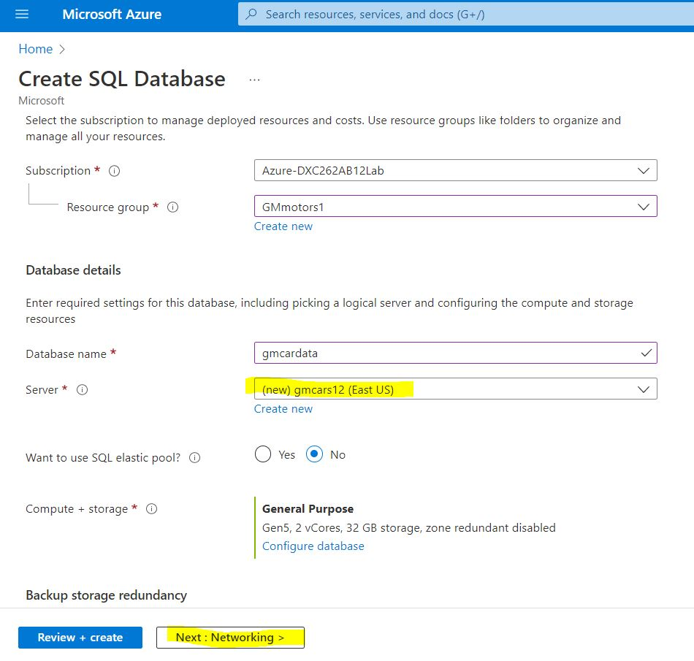

Step6: click on review and create.

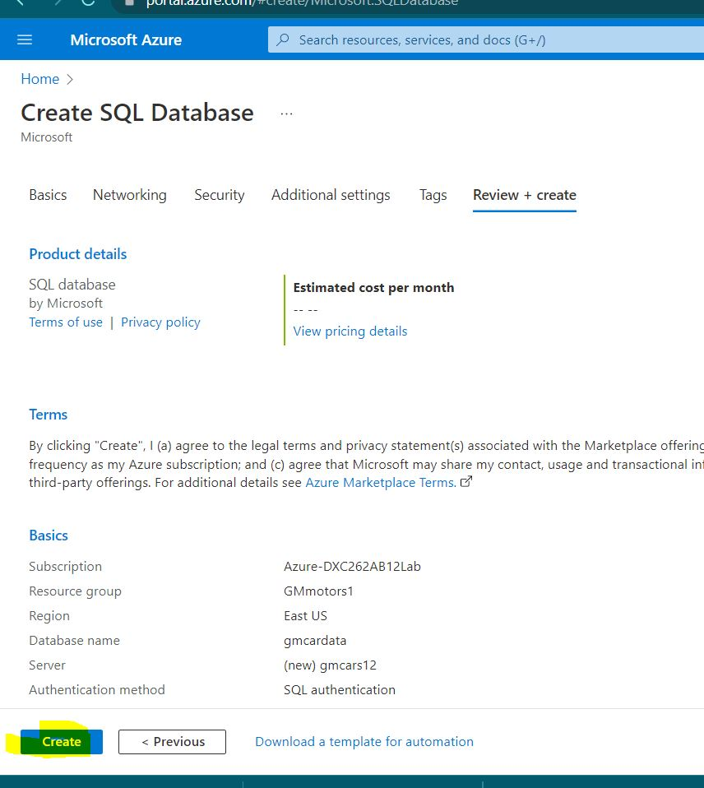

Step7: your SQL data base is created.

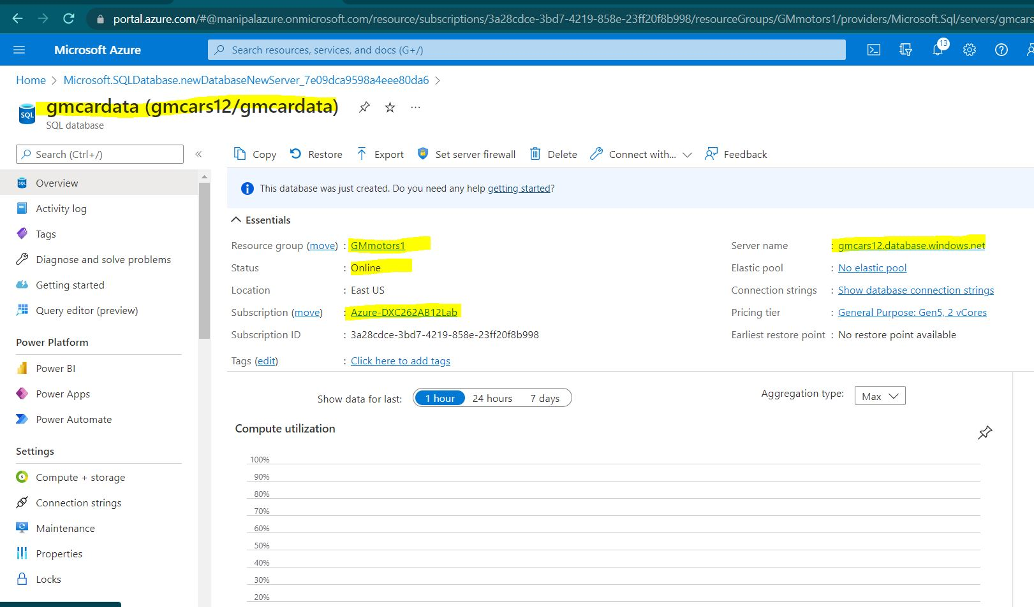

Practical Lab: Add another pipelines for moving data from Staging to **SQL DB**

Step1: Go to the data factory studio and click on injest.

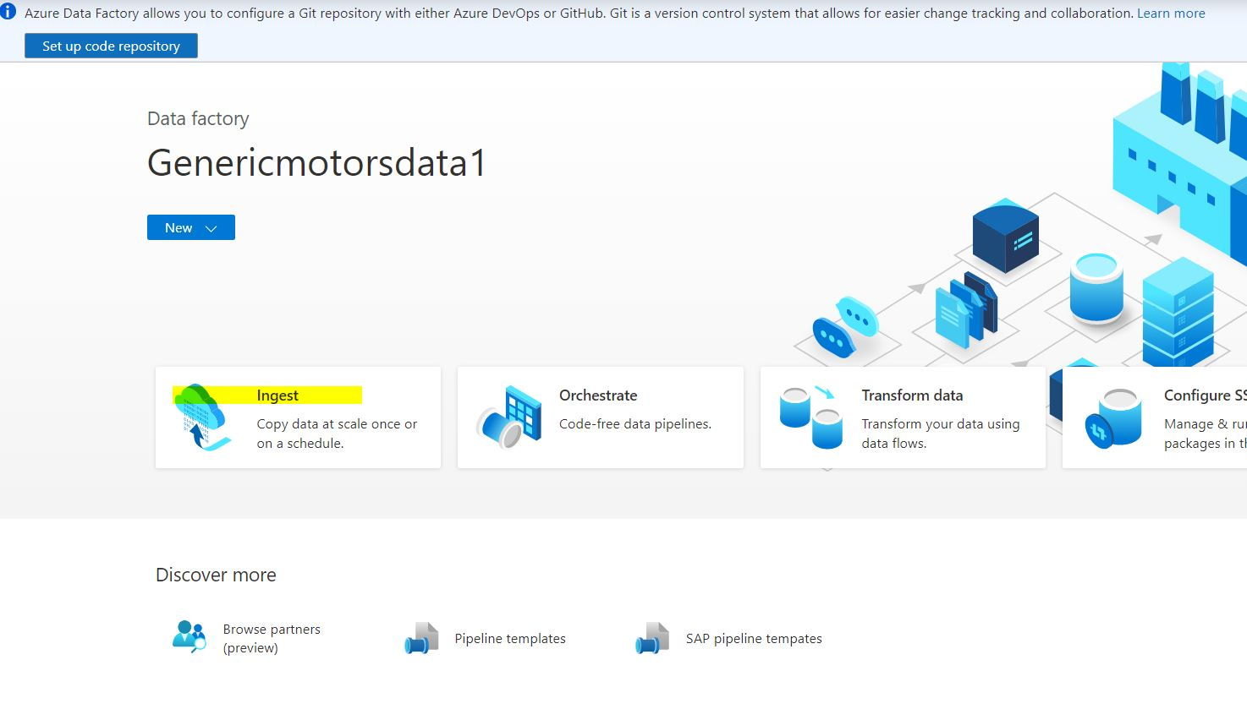

Step2: click on Built-in-copy tast , run once and click next.

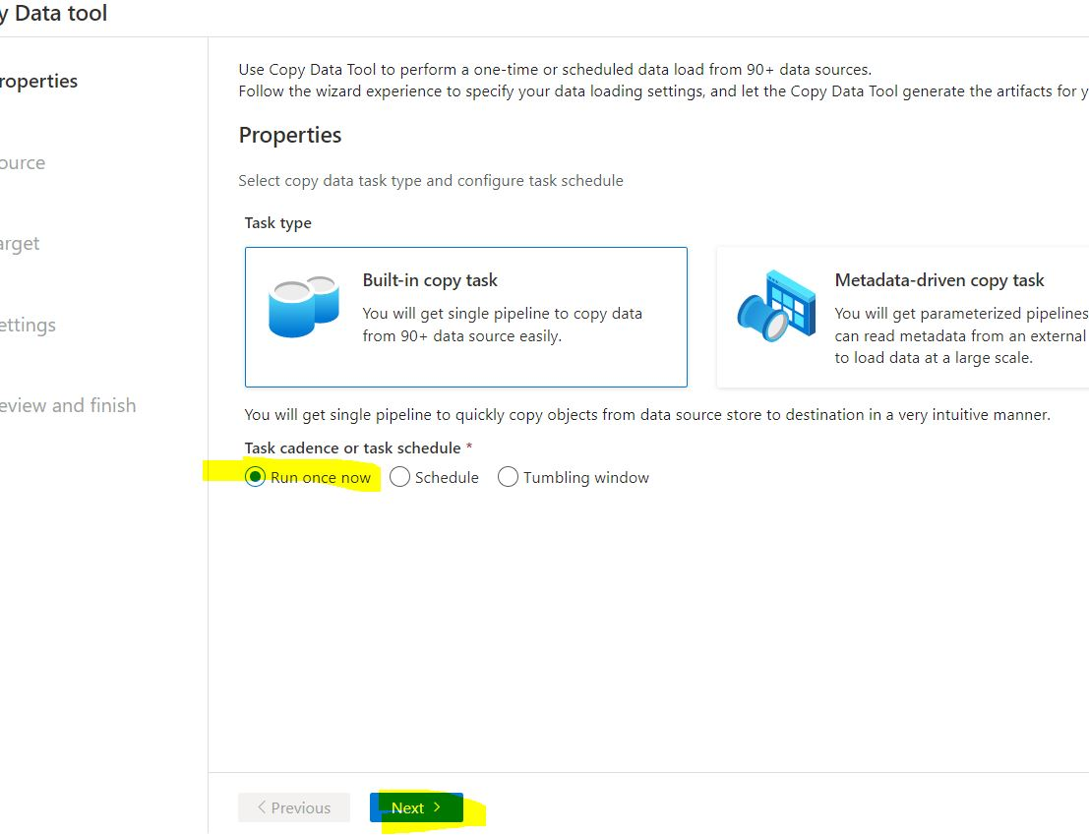

Step3: select the source type and the connection and selet file folder.

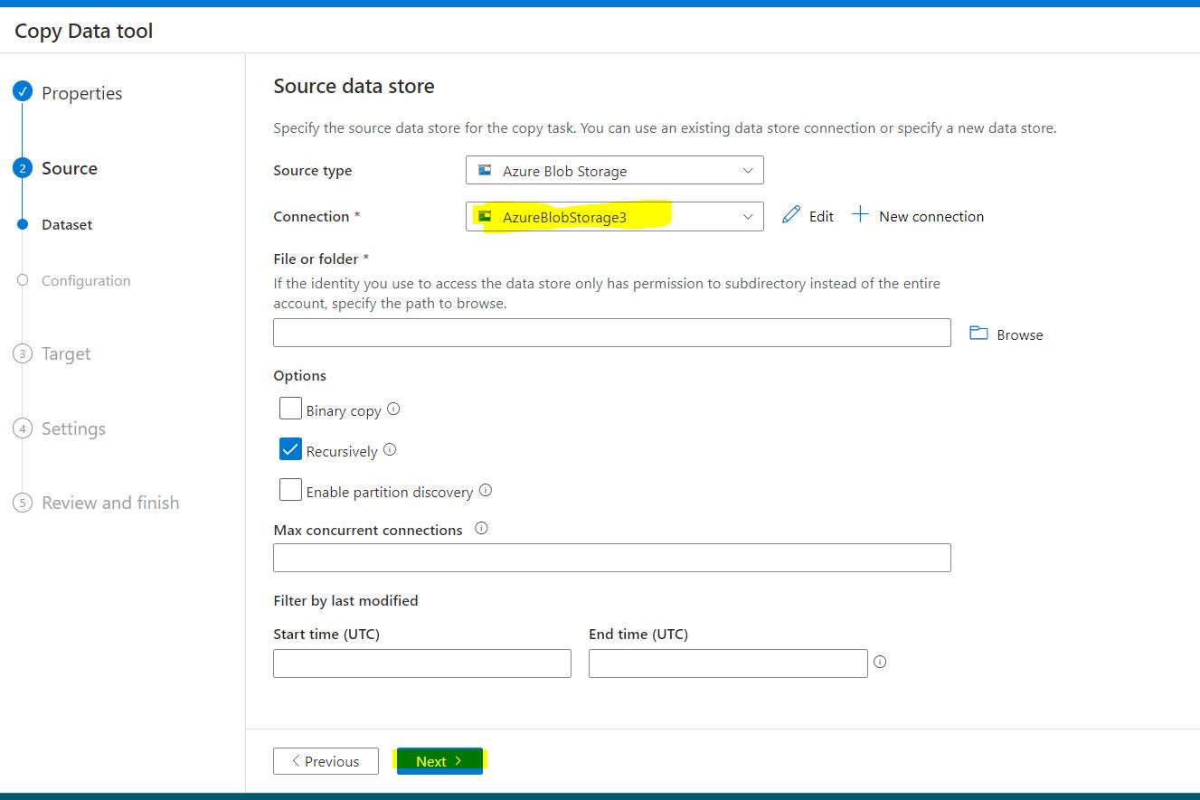

Step4: Select the destination data store as Azure SQL

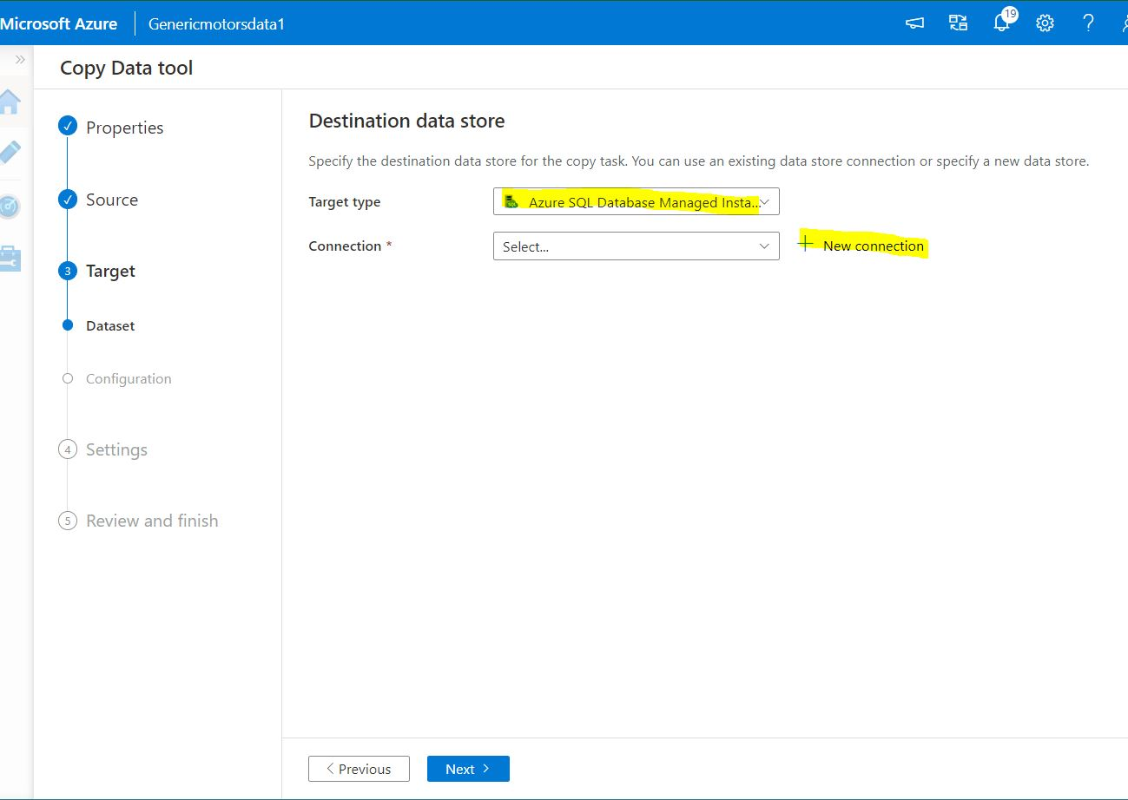

Step5: Click on new connection. Select the server name , database name , authentication type , give username and password. While checking the connection make sure that you allow the IP address of the pipeline will be allowed by the firewall of the database.

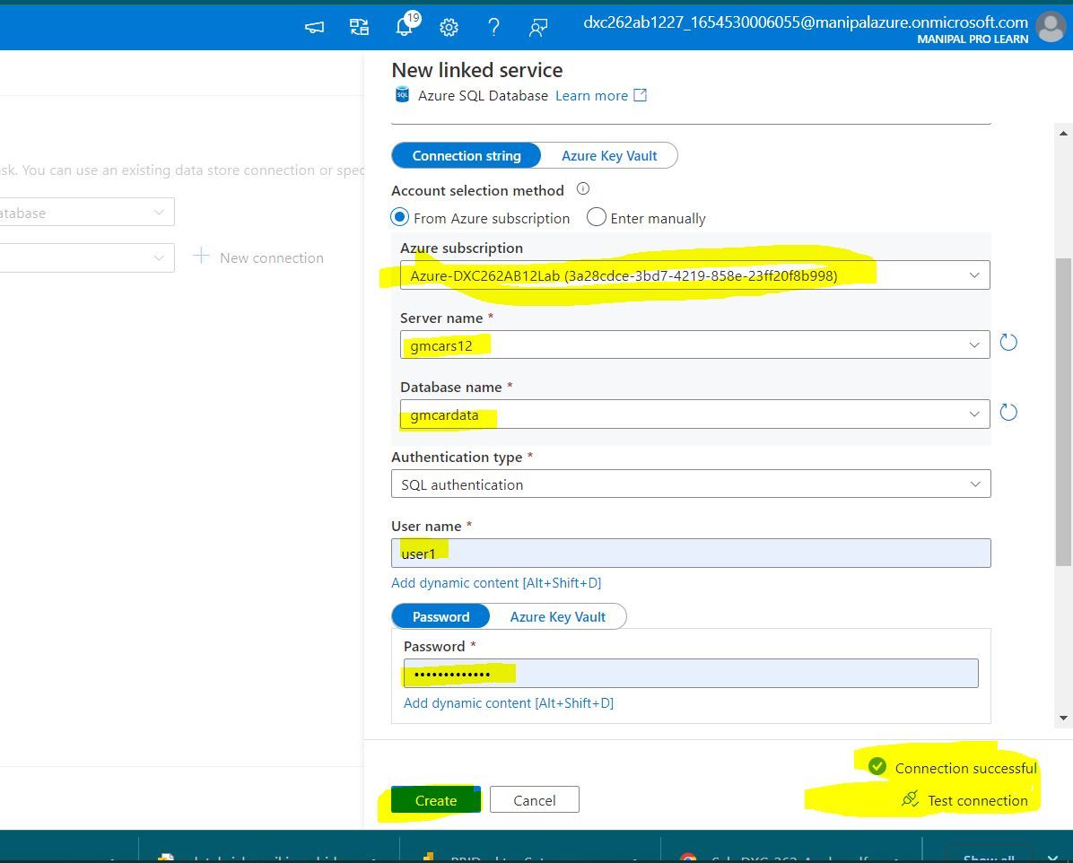

Step7: click on next.

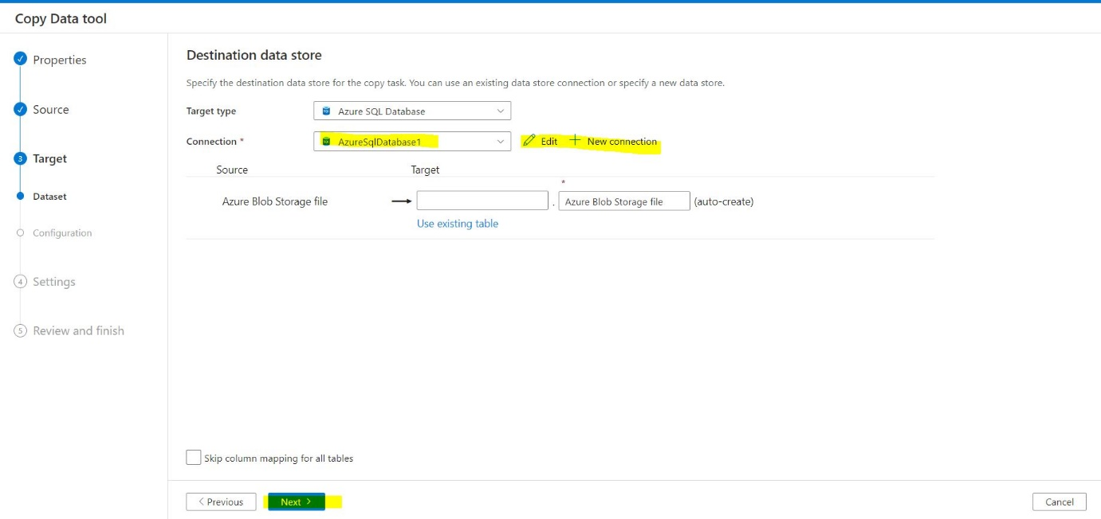

Step8: review and click on next.

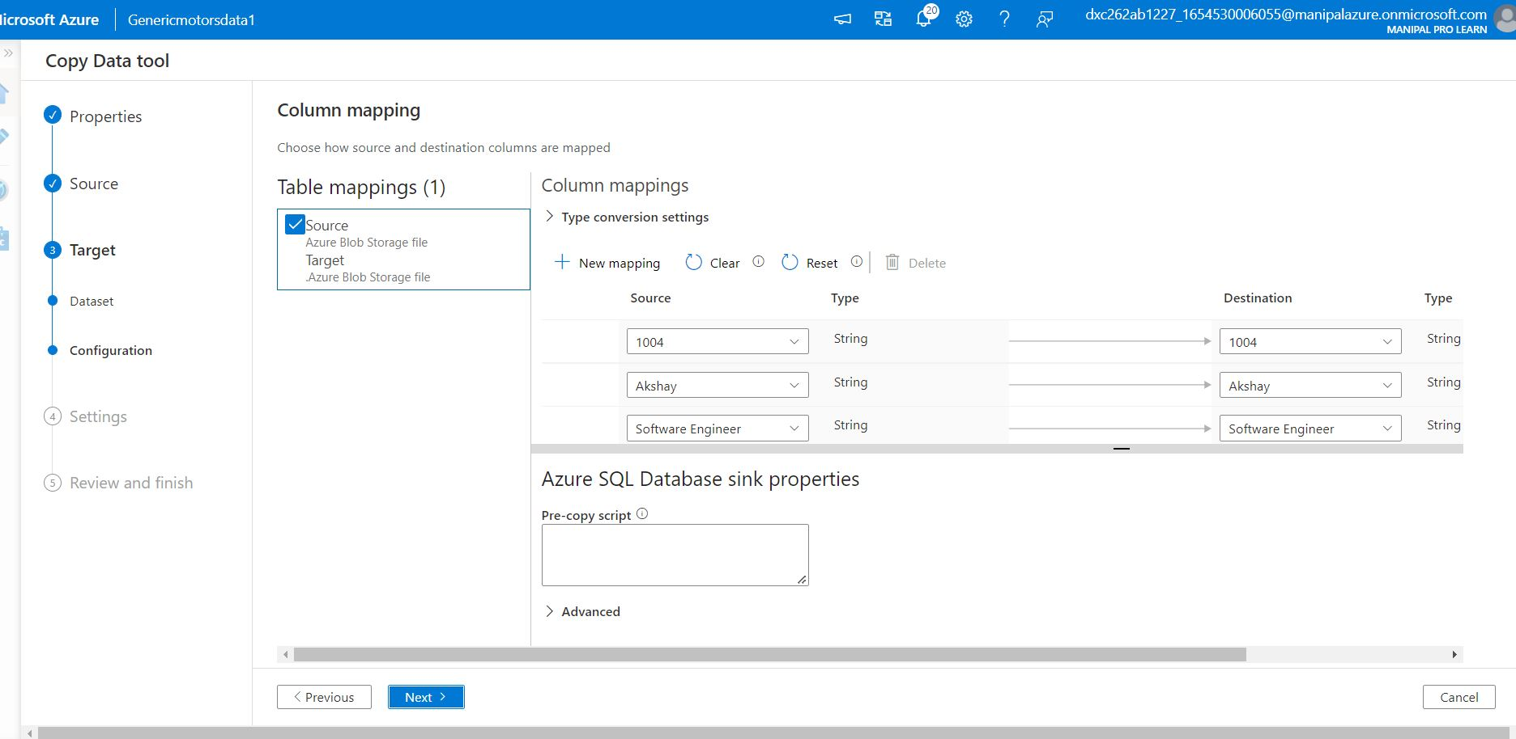

Step9: we can review the pipeline and then click on next.

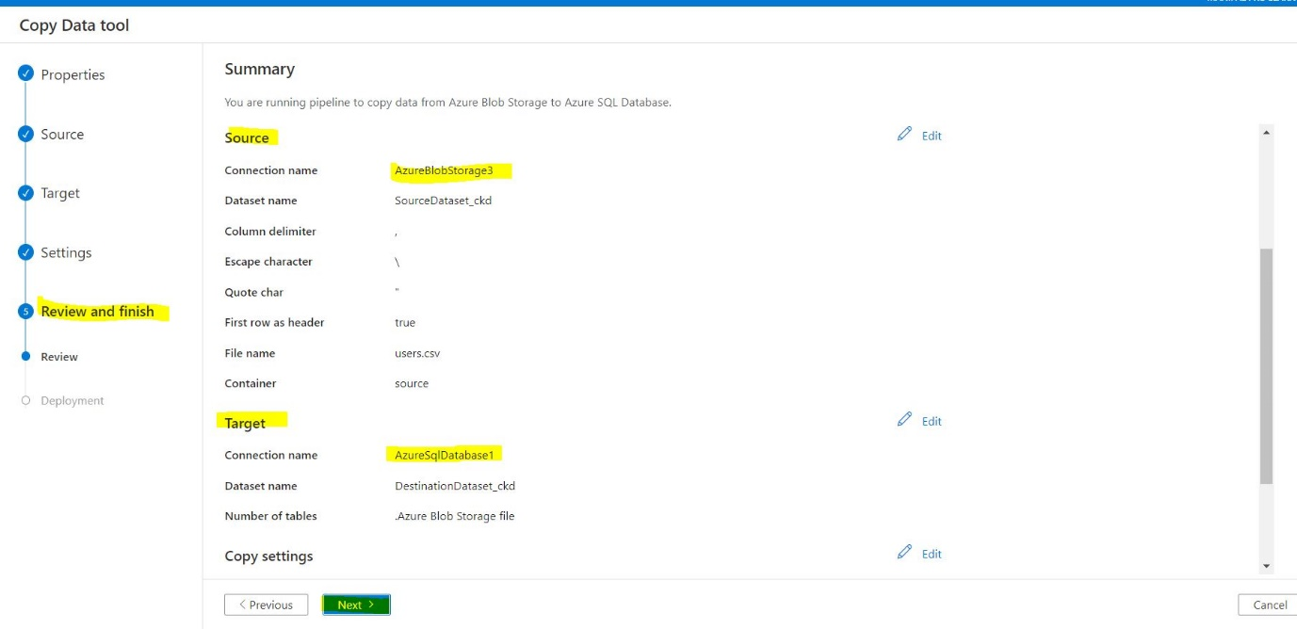

Step10: The pipeline deployment is completed.

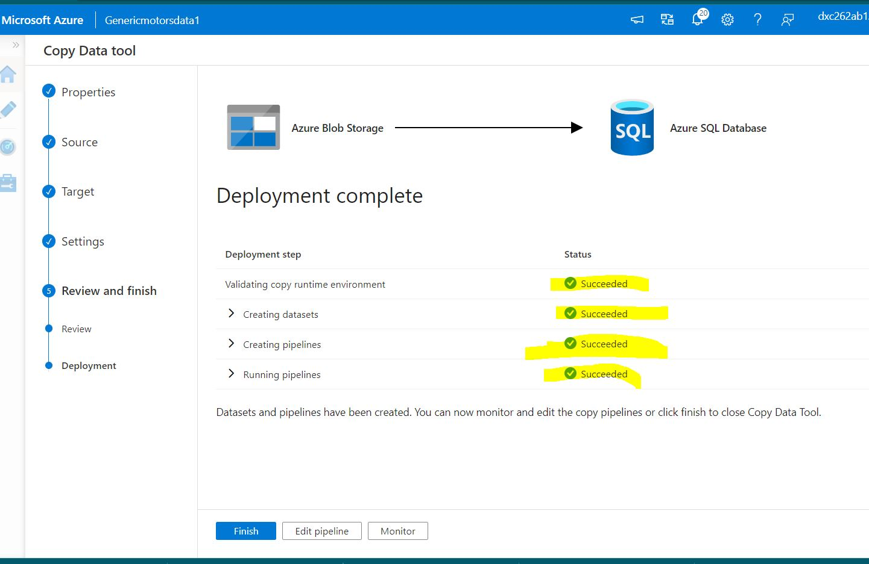

**Result:**

Most of the project requirements have been fulfilled by the step by step procedures.

**Conclusion:**

All the cases have been sloved successfully, it was so challenging when few of the pipelines got failed. After referring the error messages I’m able to run the pipelines successfully and had a great experience while learning the concepts in deep.

Apart of the demonstrations that were explained in the tutorials I’m able to perform a variety of new operations with a lot of enthusiasm and engagement in learning.

Name: Sai Kiran Anche

Reg No: DXC262AB12021

**Project2 Name: AP Morgan Data Platform**

Date: June 10,2022.

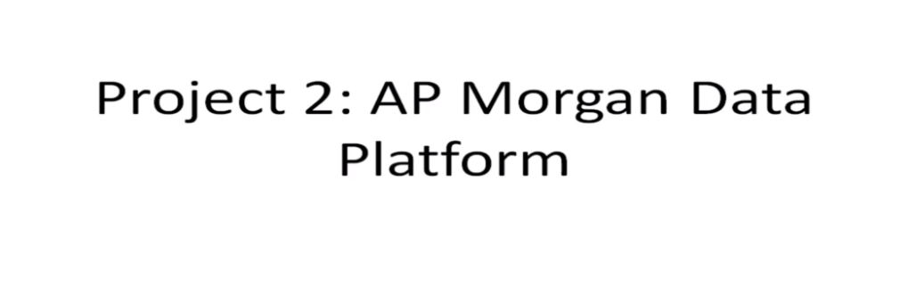

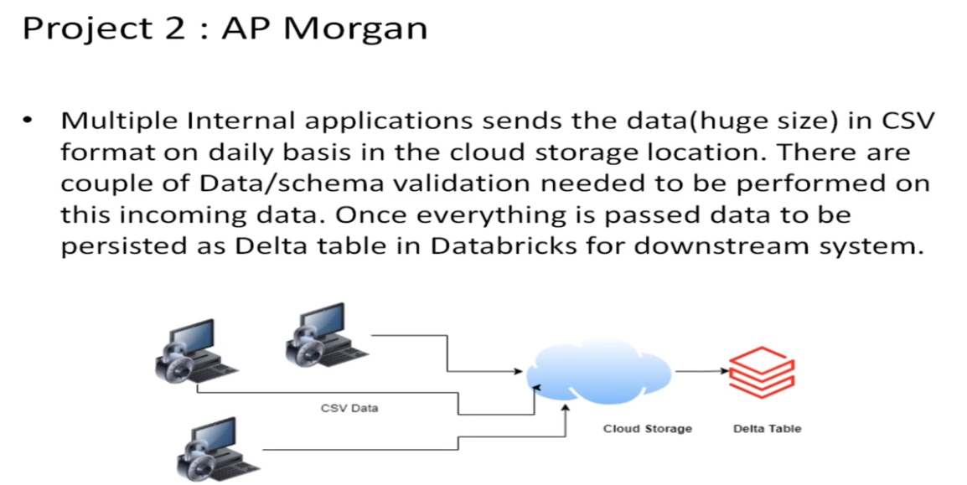

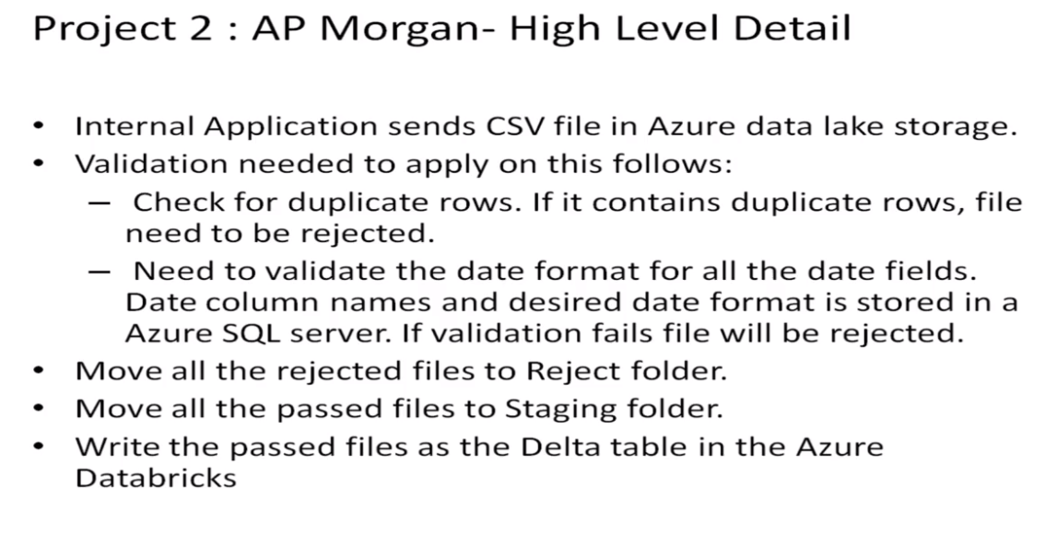

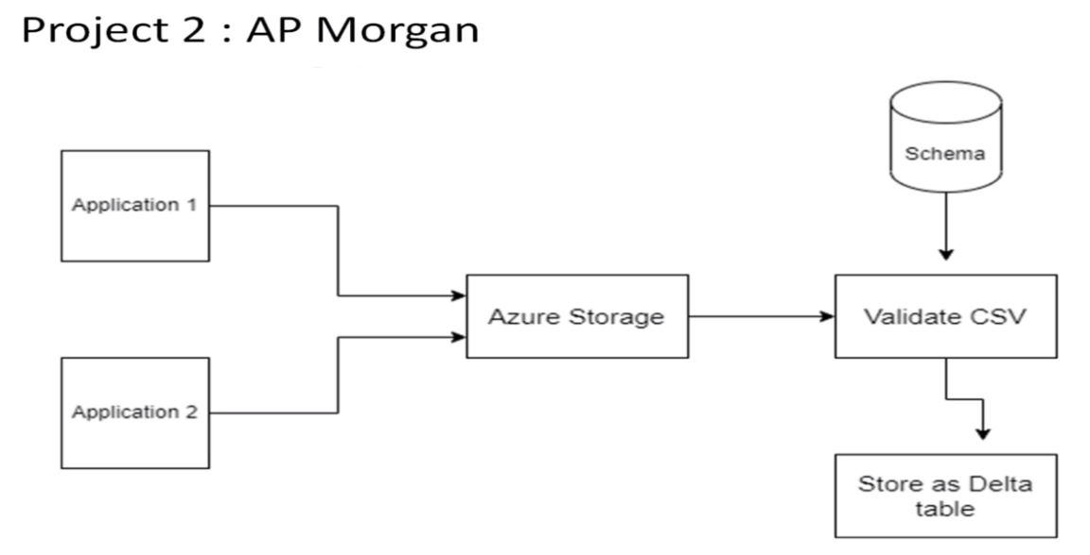

Practical Lab: Create a **Databricks**

Step1: Goto *portal.azure.com* and search for azure data bricks.

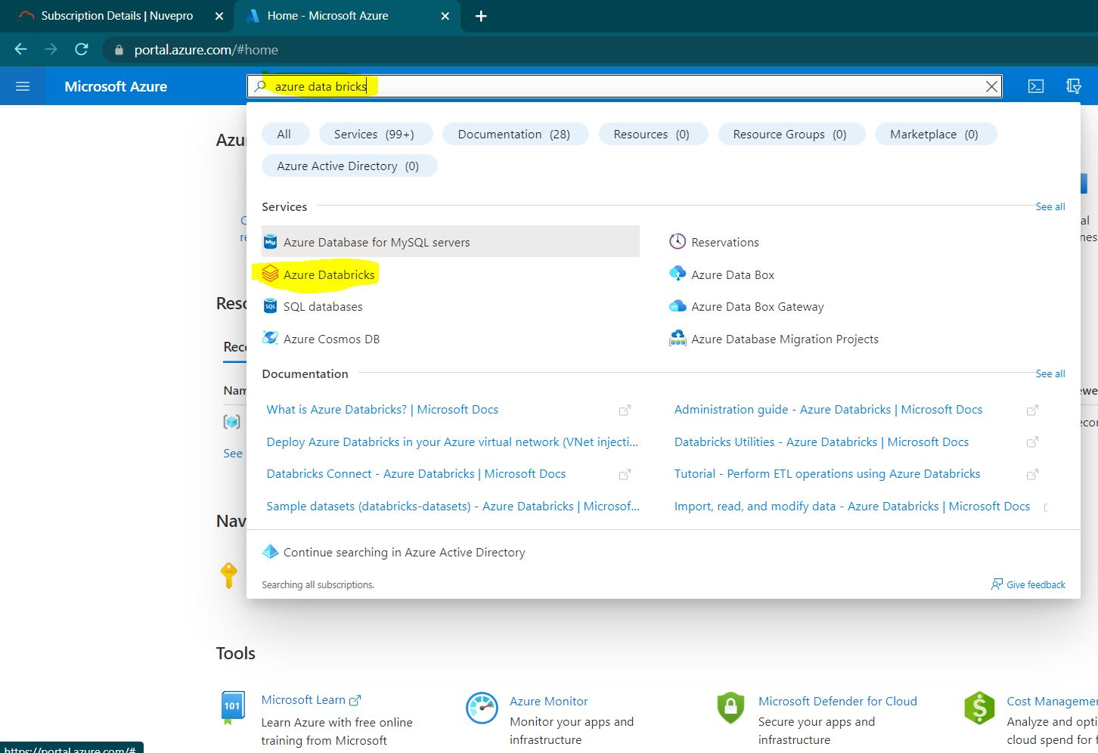

Step2: click on create button.

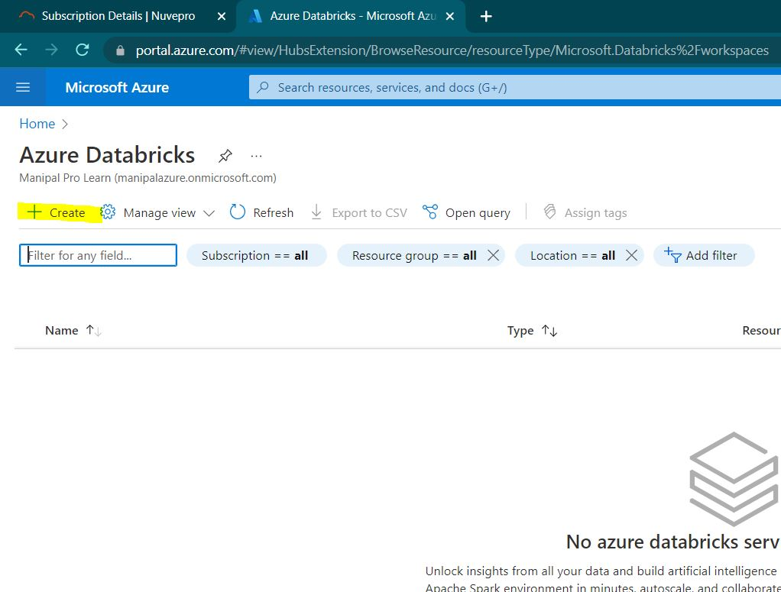

Step3: Create a new resource group for the AP morgan group.

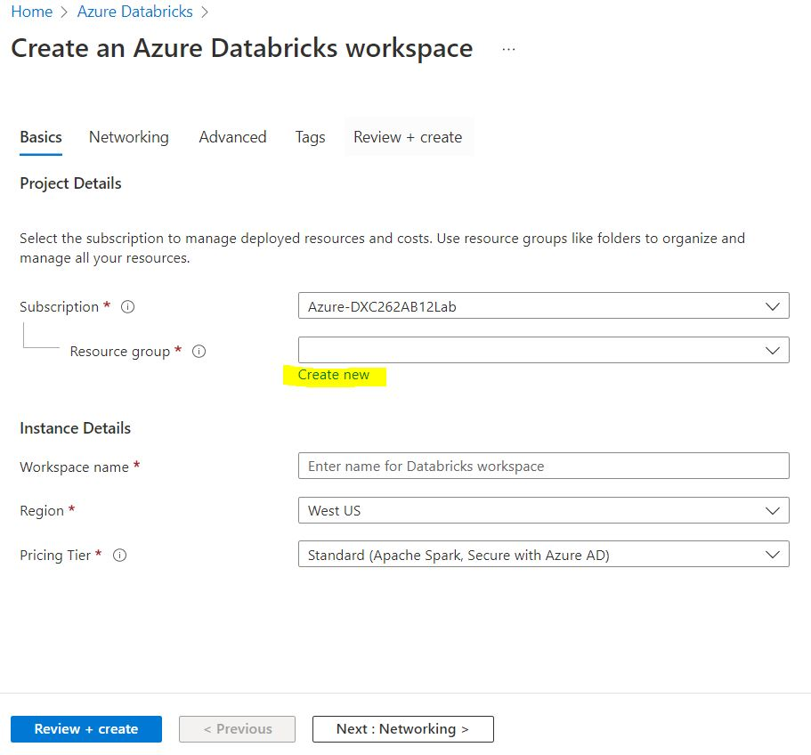

Step4: give the name for the workspace and choose pricing tier as trial and later click on review and create.

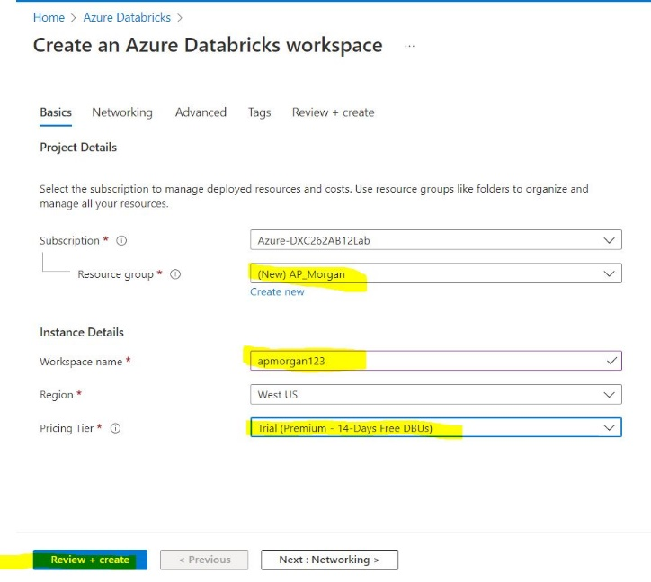

Step5: after successful validation click on create button.

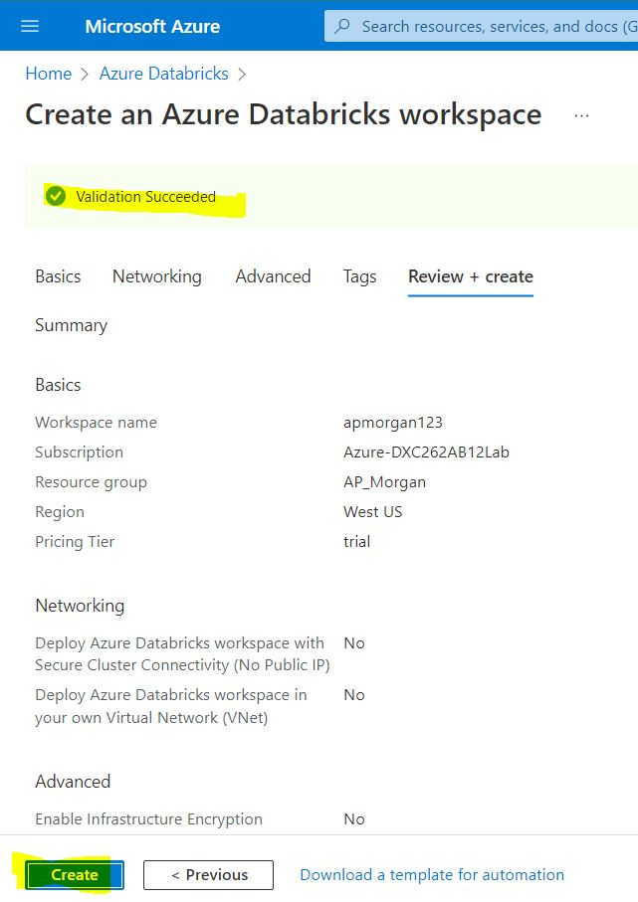

Step6: the deployment of the data bricks has been completed.

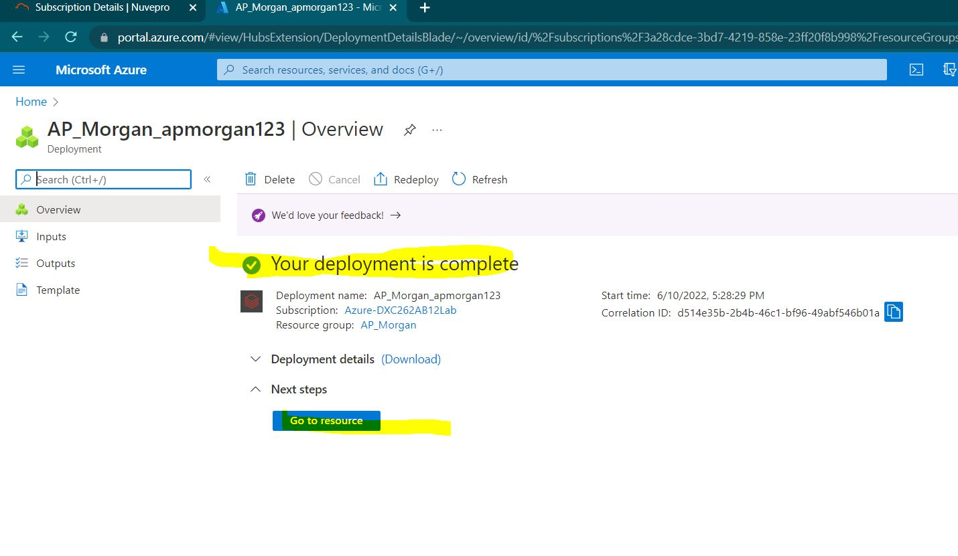

Practical Lab: Create **Cluster in Azure Databricks**

Step1: goto overview of the data bricks deployment and click on launch workspace.

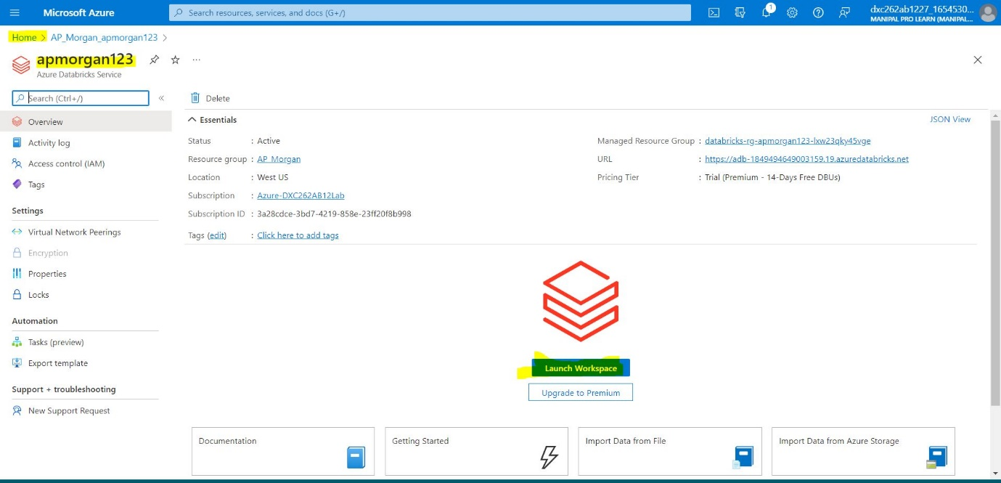

Step2: choose an account to sign into the data bricks workspace

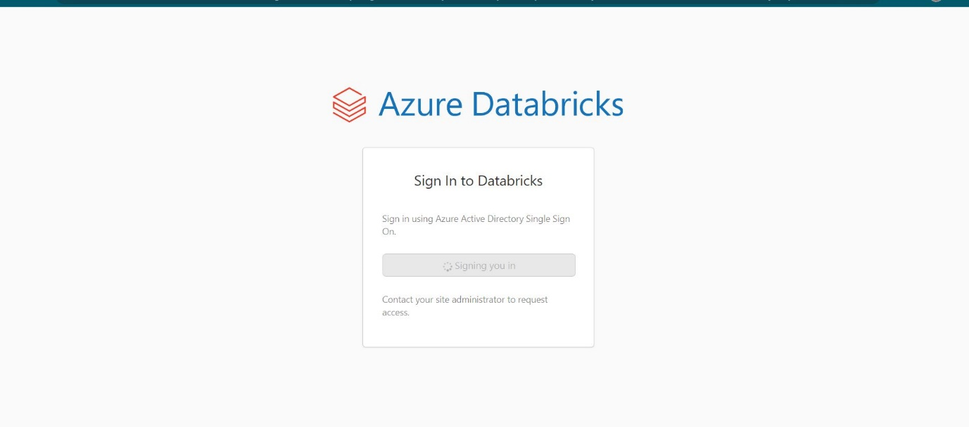

Step3:Click on the create button in the menu and click on cluster

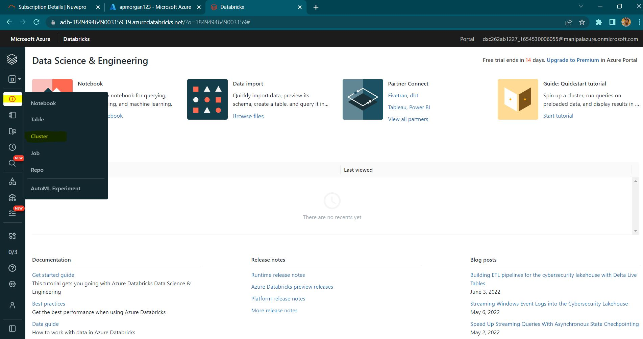

Step4: name the cluster, choose your required cluster mode and set termination time , then on create button.

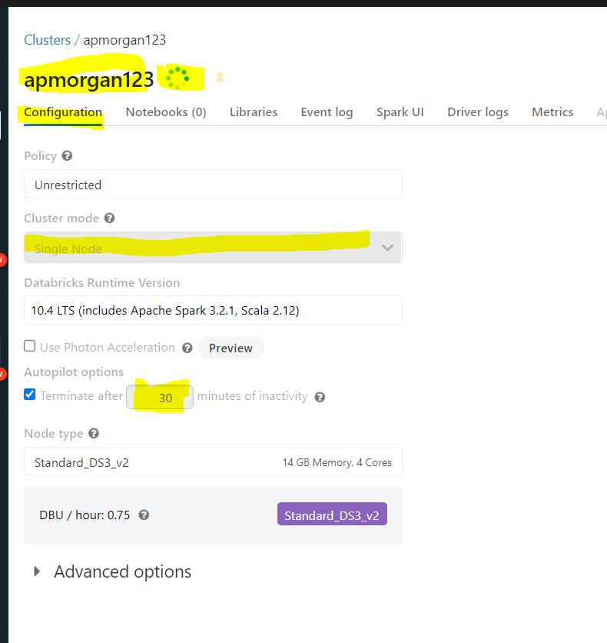

Step5: after successful creation of the cluster the green tick mark appears near the cluster name.

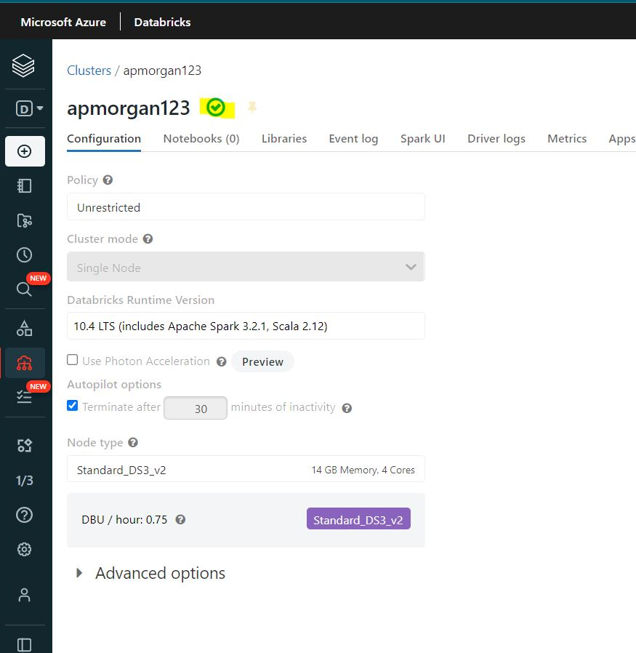

Practical Lab: **Add notebook in Databricks** and Implement the Business Logic

Step1: Go to create in the data bricks workspace.

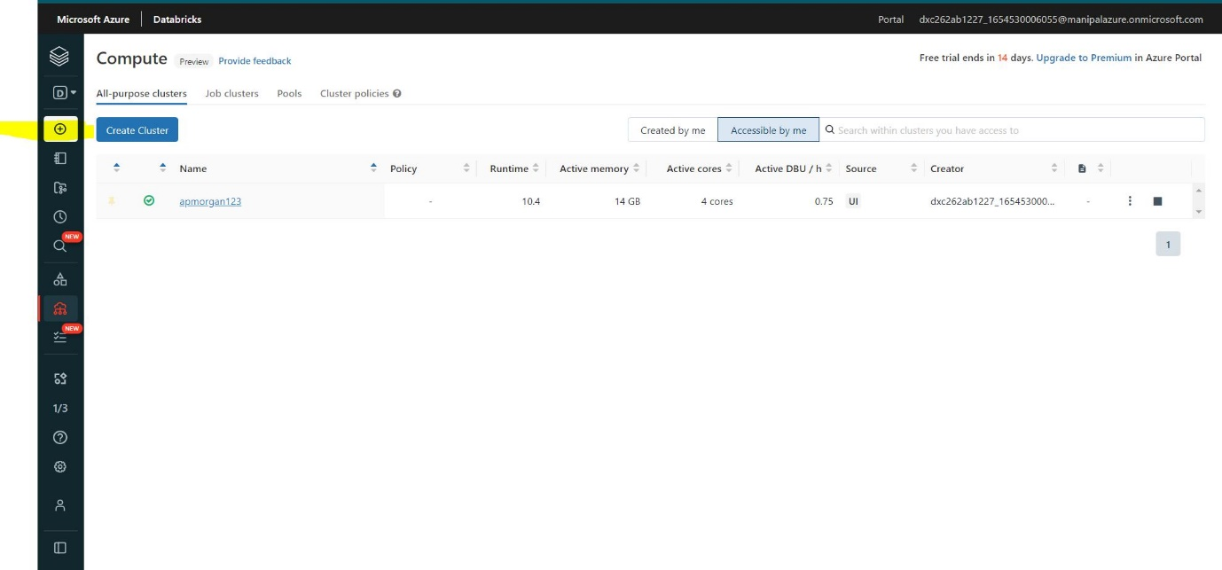

Step2: select notebook.

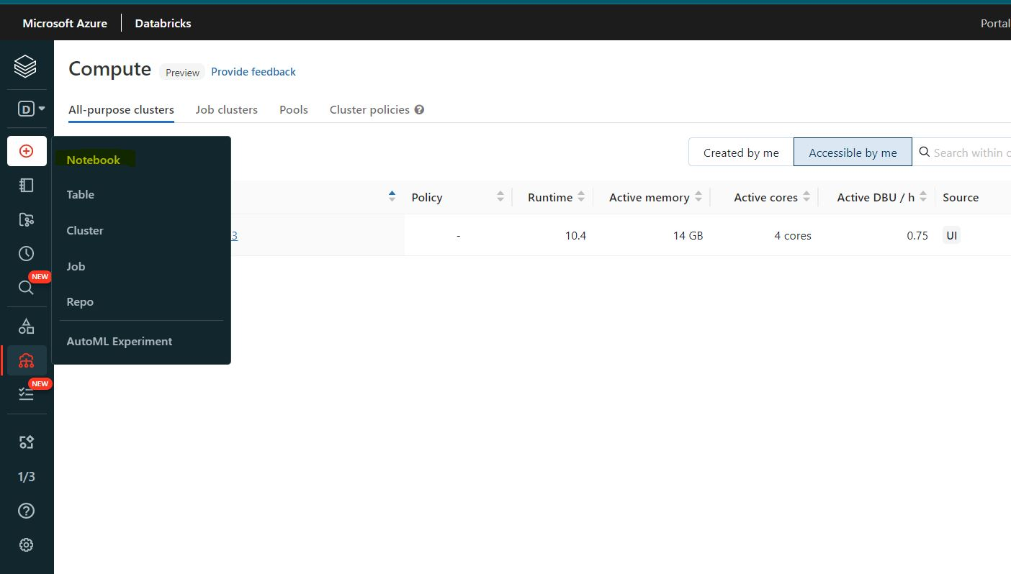

Step3: name the notebook and assign the cluster to it.

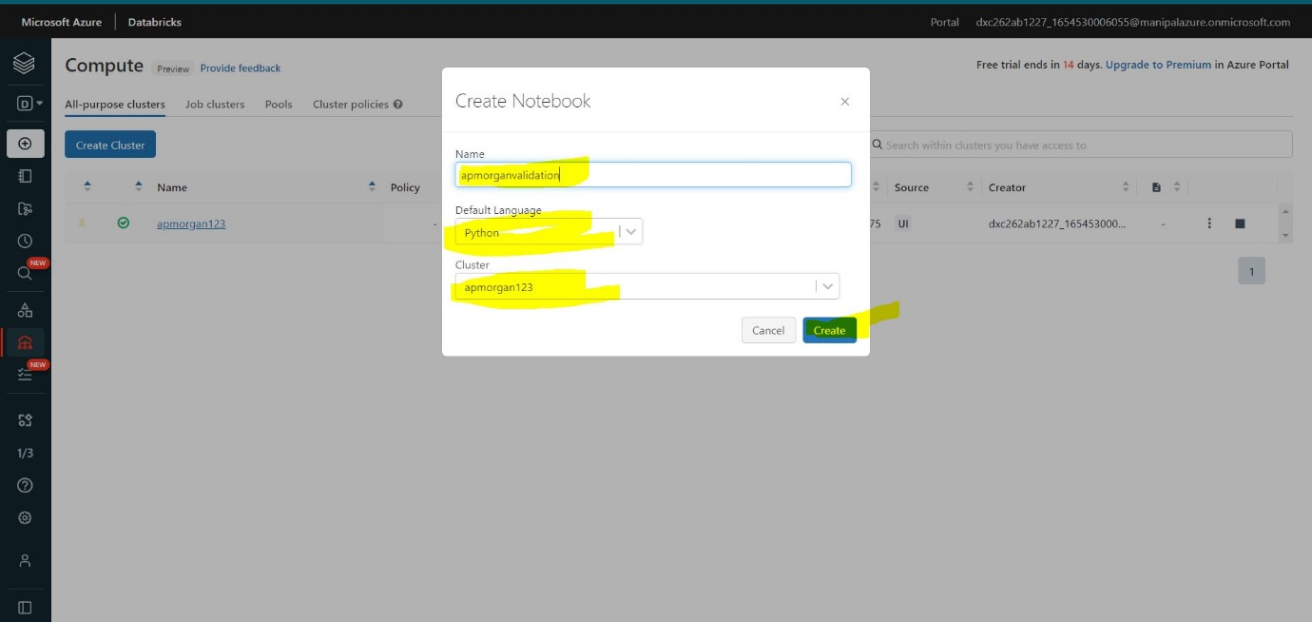

Step4: You can now implement your business logic in the notebook provided.

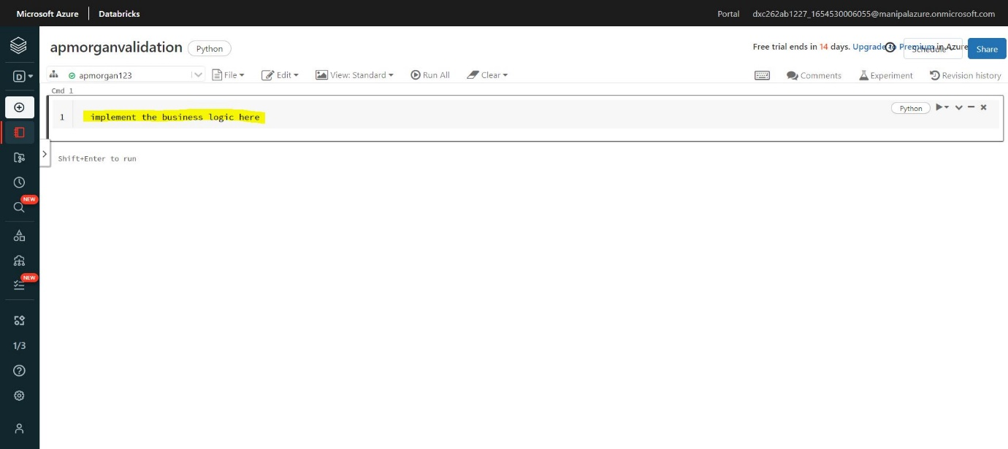

Practical Lab: **Azure Data Factory** For AP Morgan

Step1: Goto portal.azure.com and search data factories.

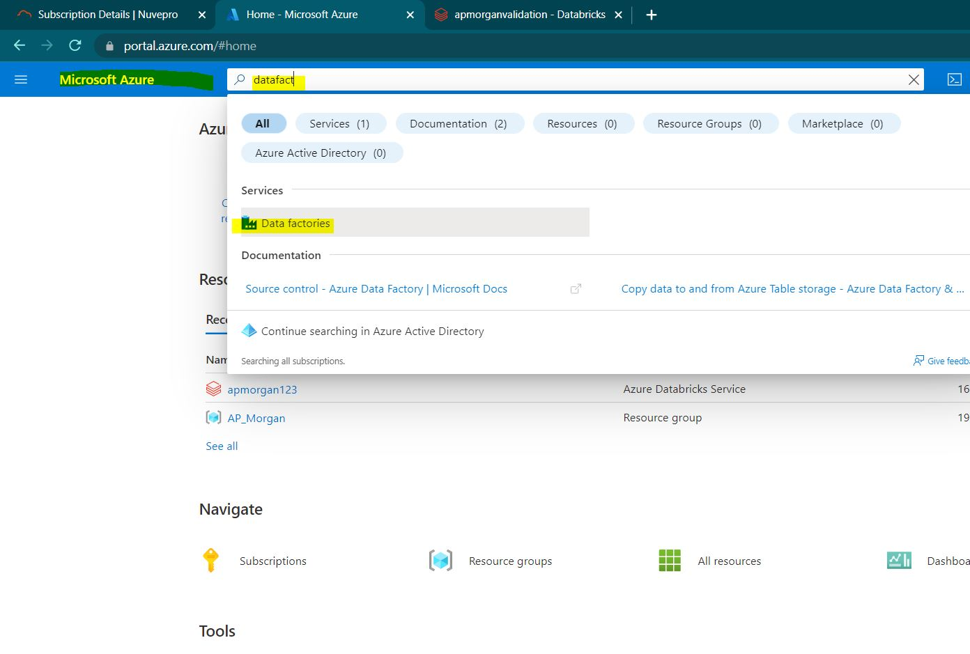

Step2: click on the create button.

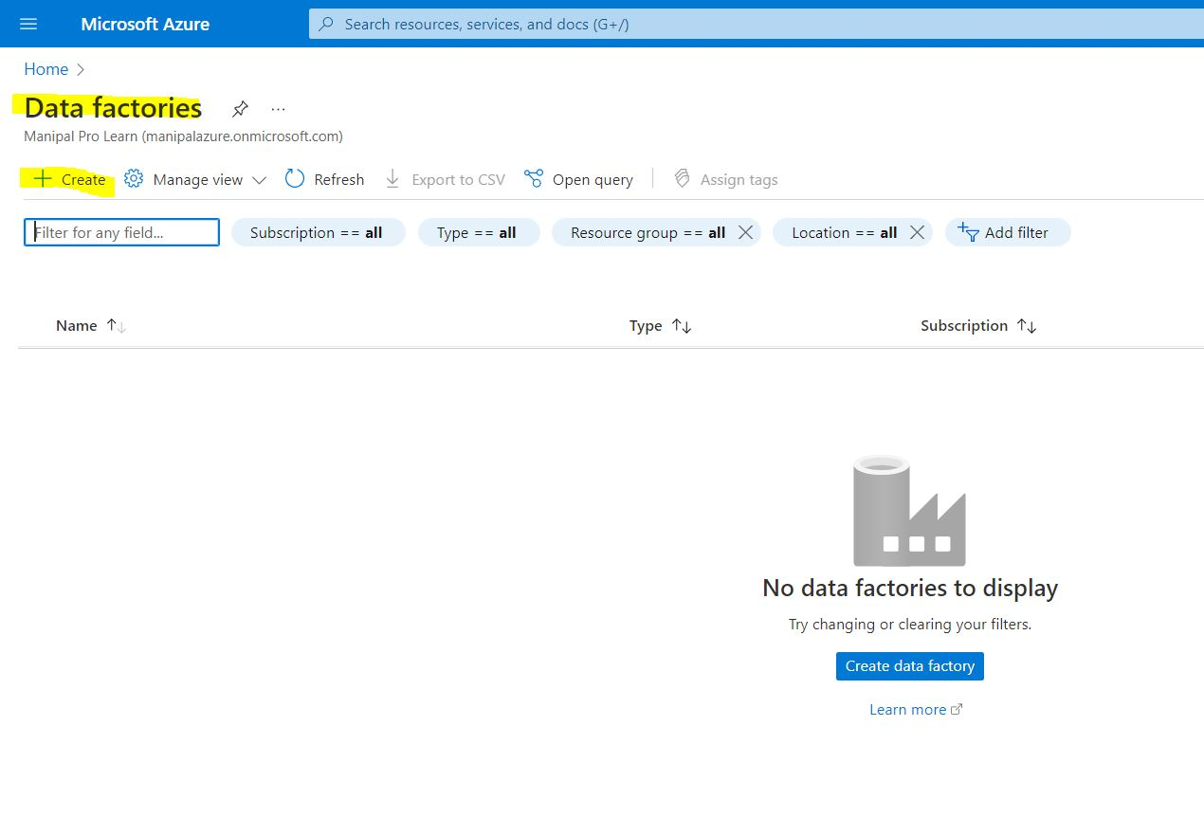

Step3: give the project details as well as the instance details and click on git configuration.

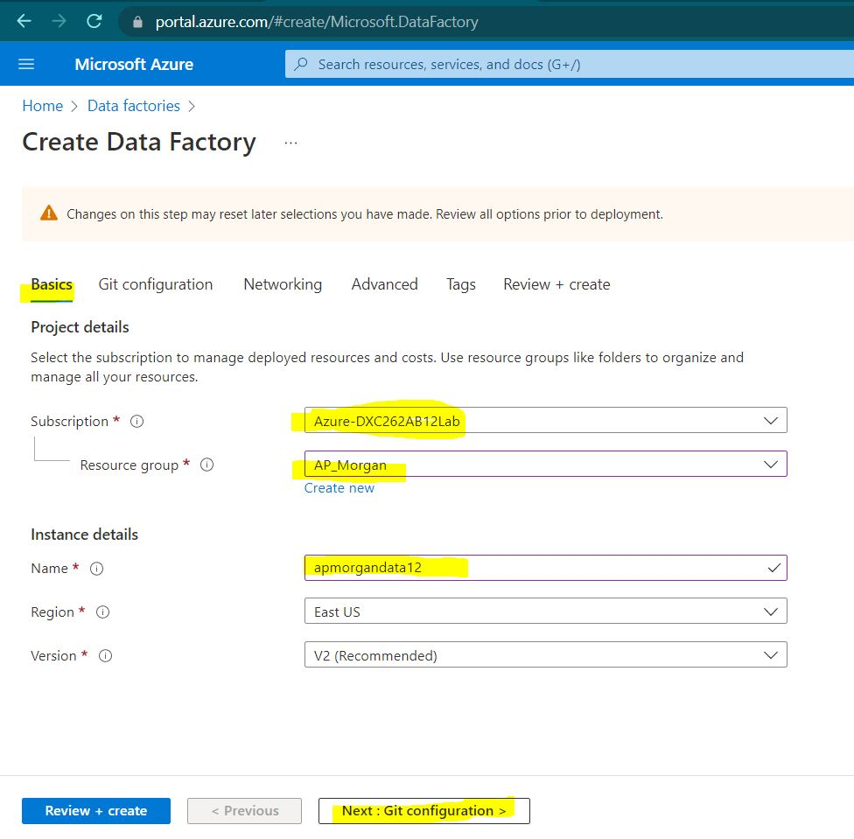

Step4: click on configure git later and later review and create.

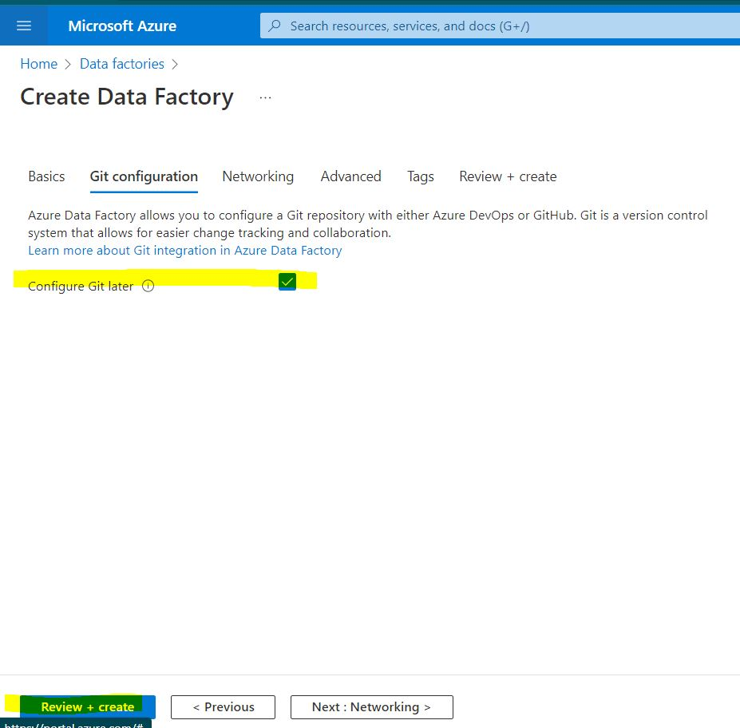

Step5: after successful validation click on create button.

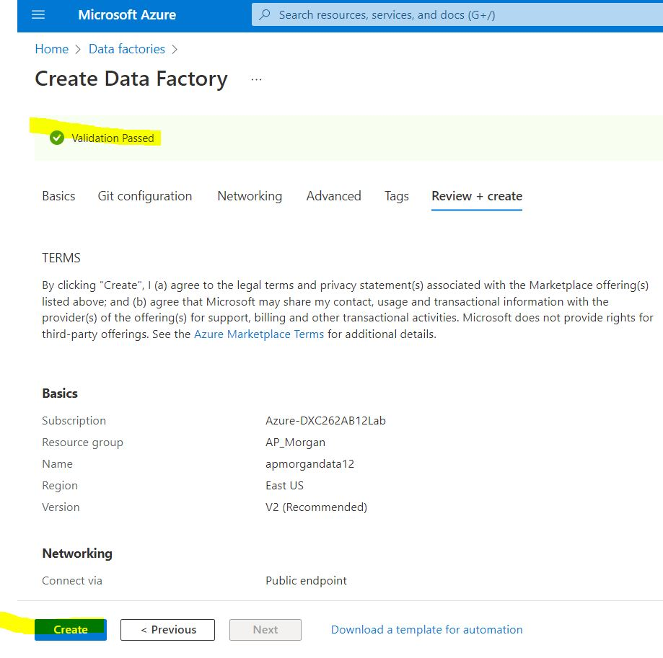

Step6: your data factory is created.

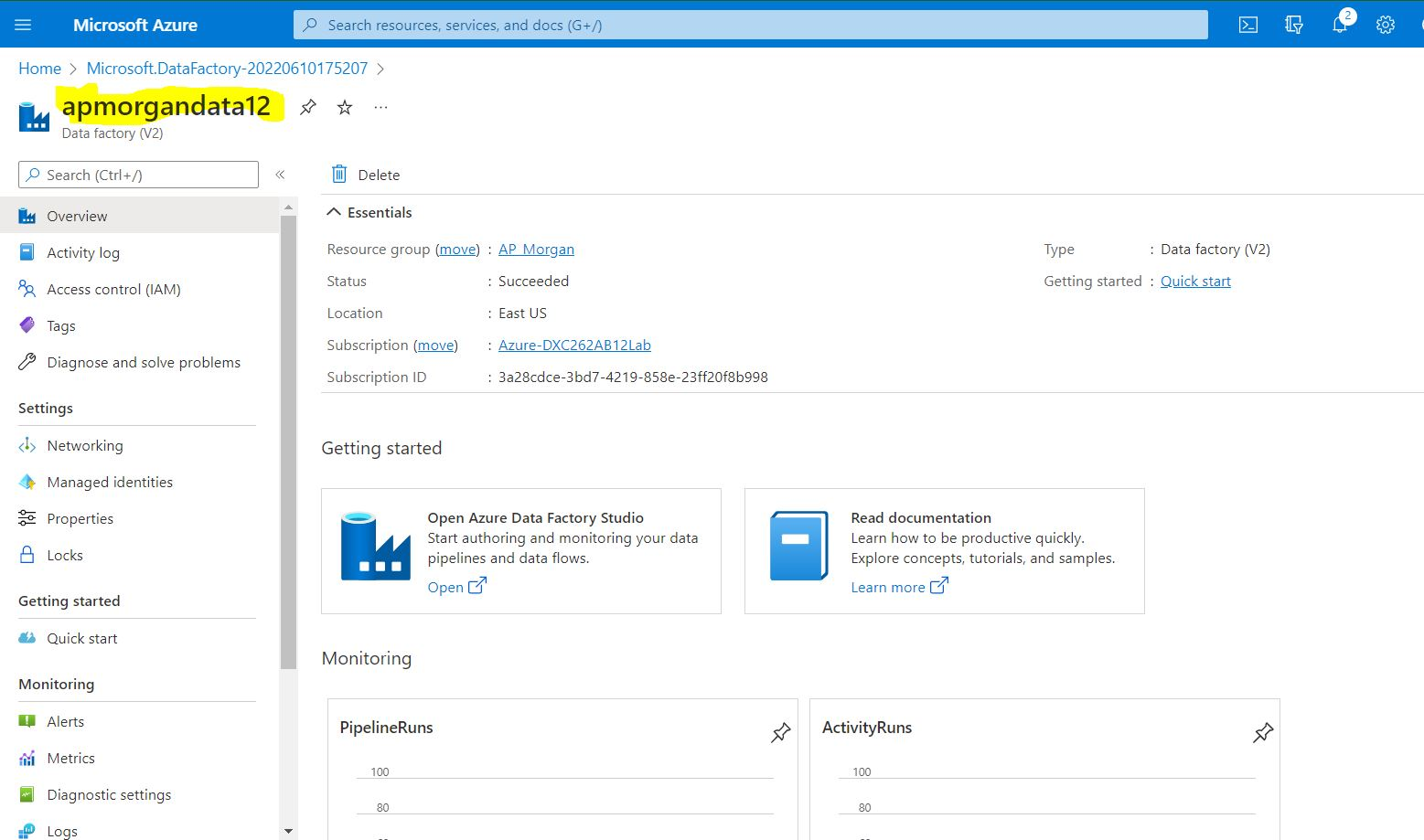

Practical Lab: **Create Azure Databricks** Linked Service in ADF

Step1: open the overview page of the data factory and click on the azure data factory studio.

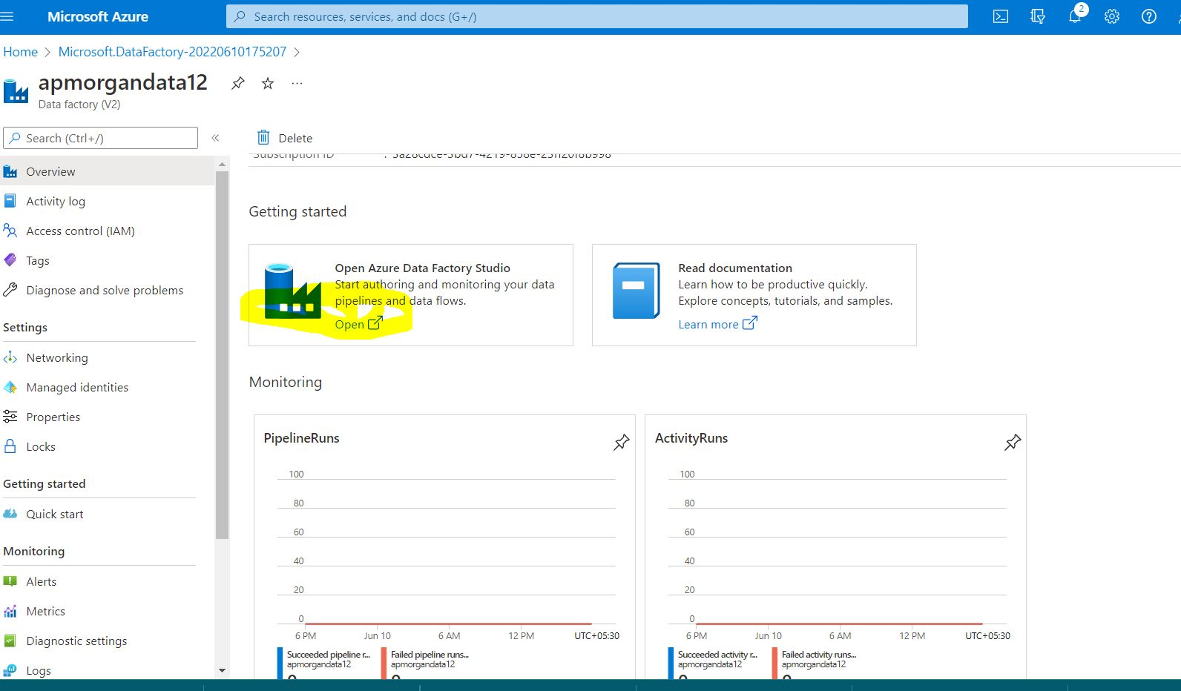

Step2: Click on compose button.

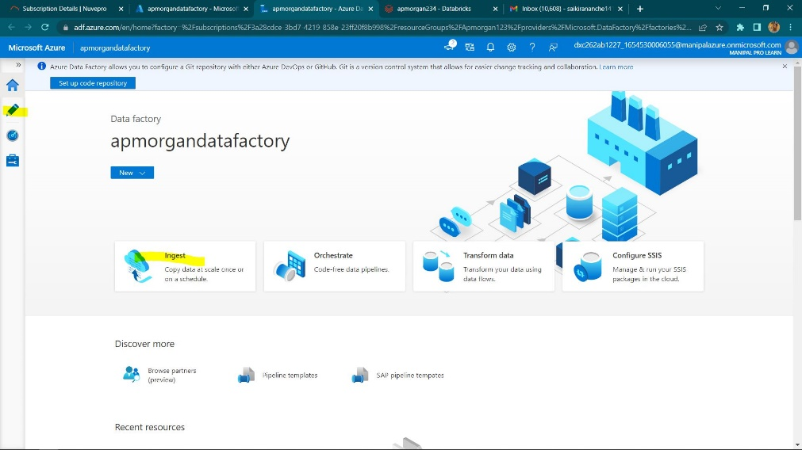

Step3: click on the + symbol

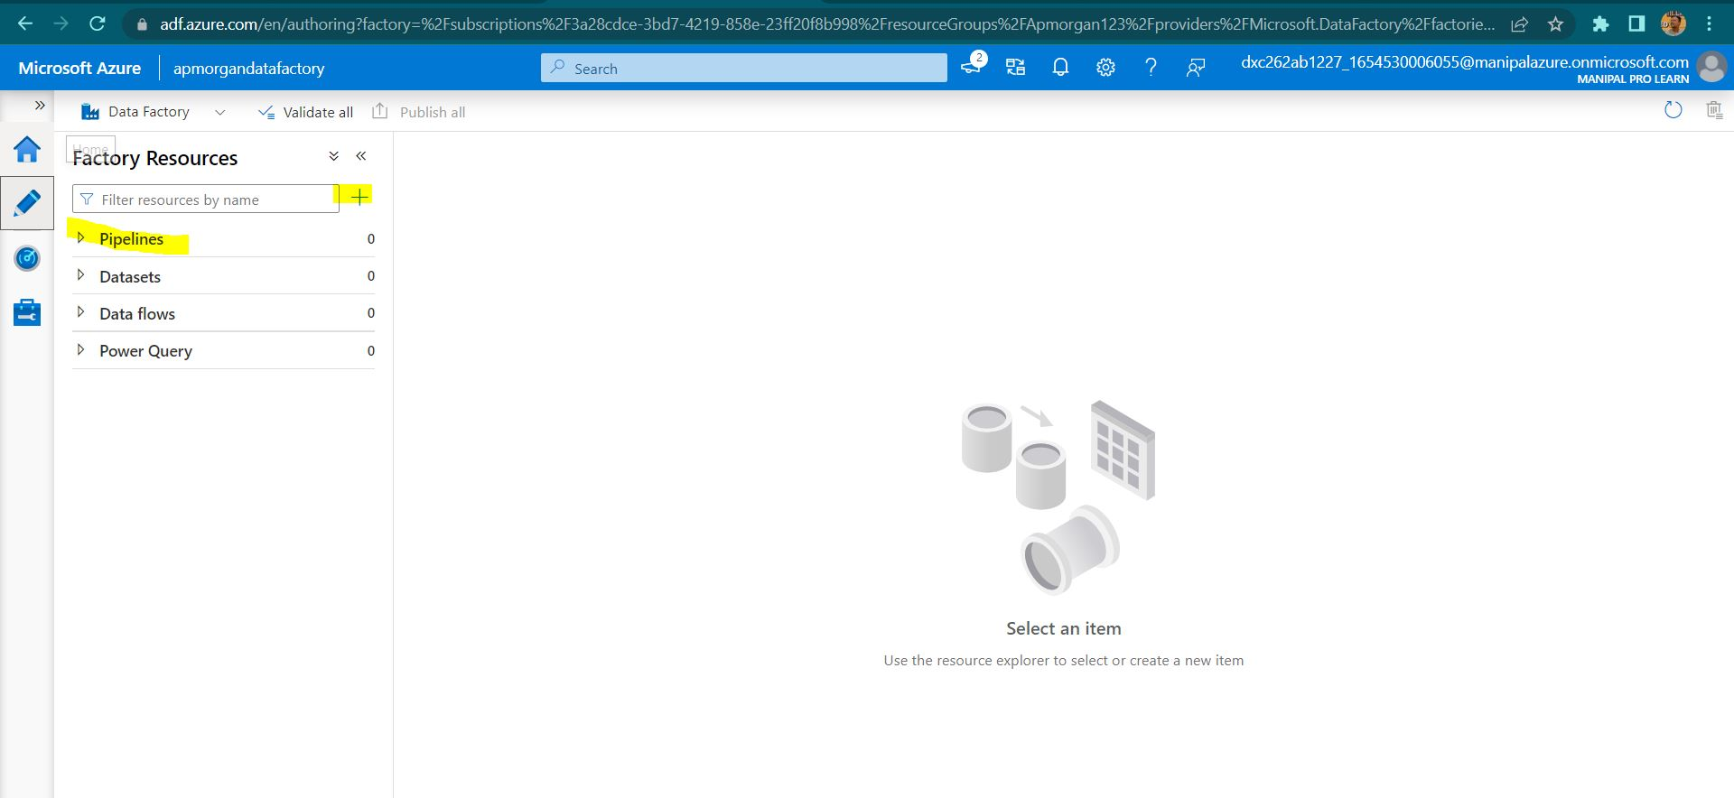

Step4: click on pipeline> choose pipeline again

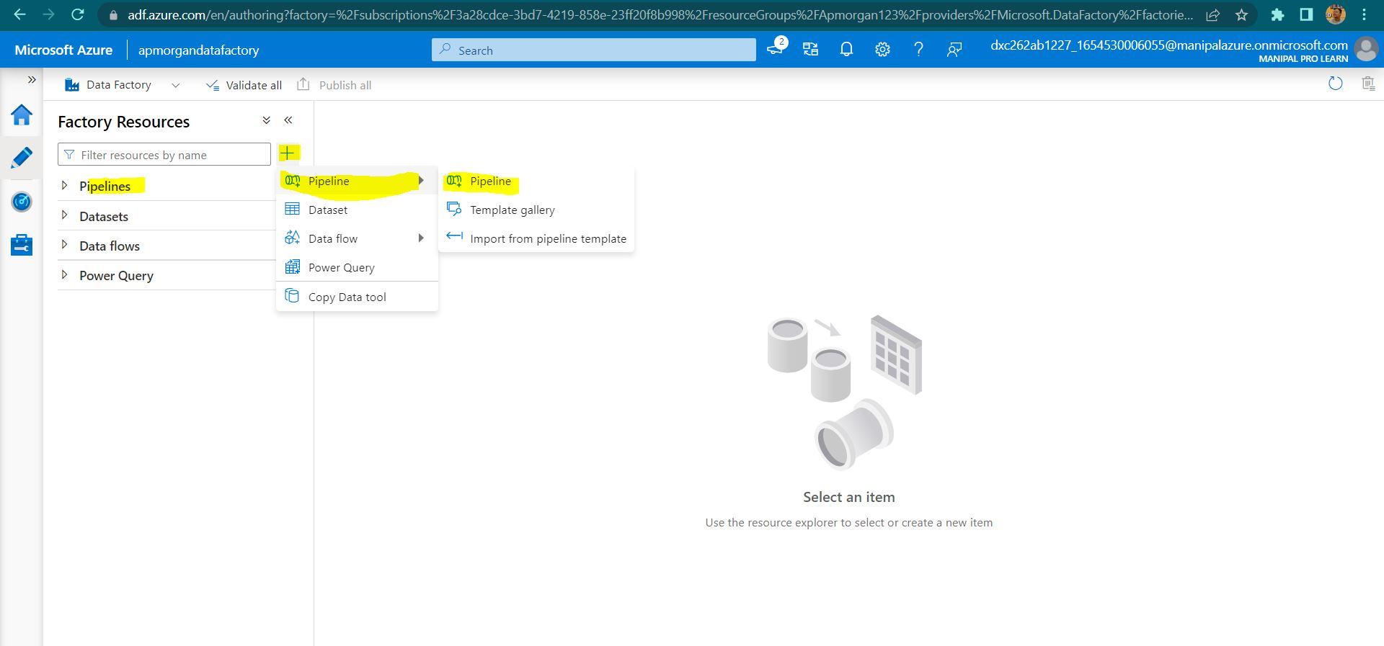

Step5: Choose databricks , Notebook under the activities.

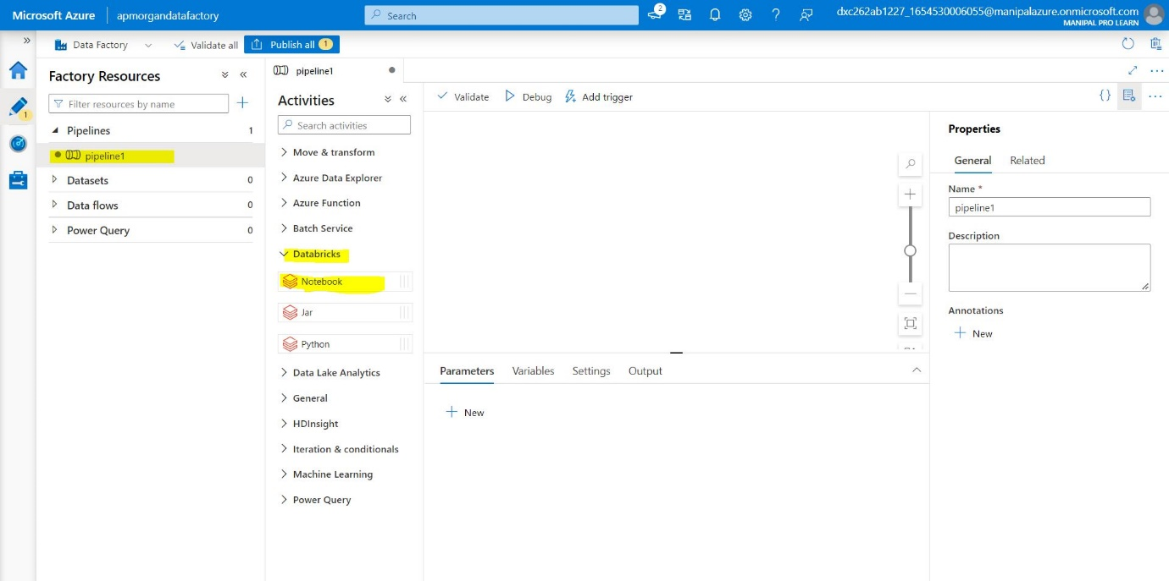

Step6: drag and drop the notebook in the space provided.

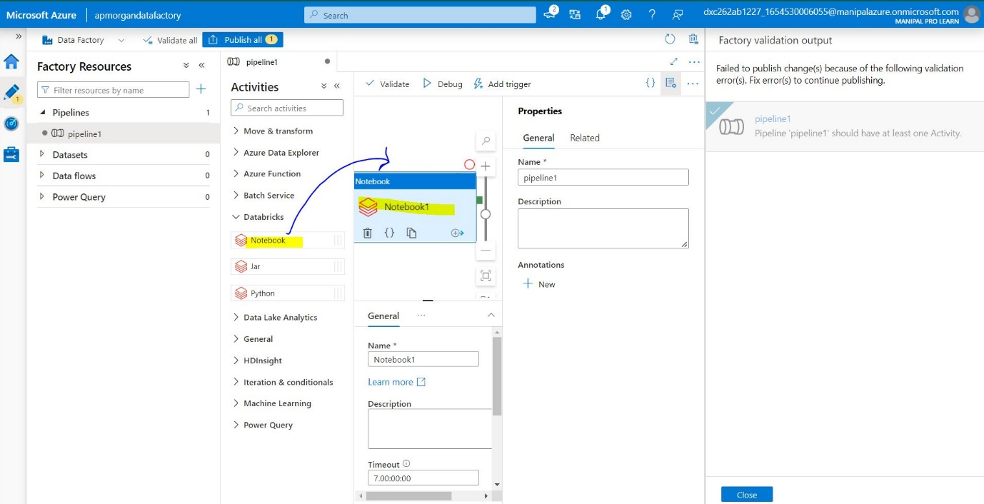

Step7: click on azure data bricks and select the new option near data bricks linked service.

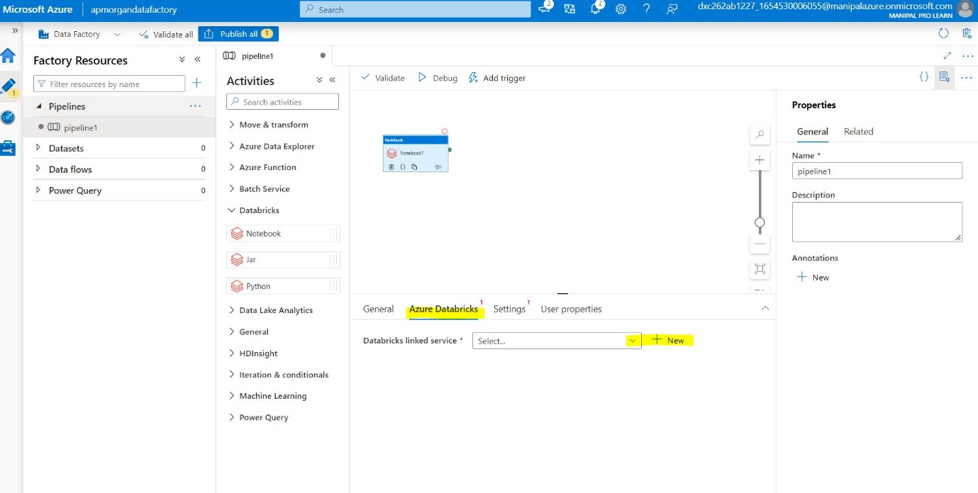

Step8: select the workspace , azure subscription, databricks workspace URL. Select authentication type as Access token.

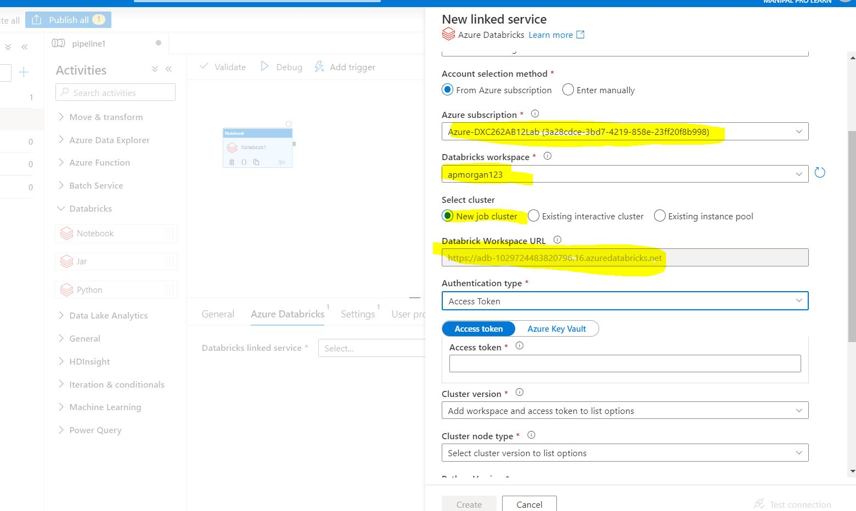

Step9: open the data bricks workspace , click on settings , user settings.

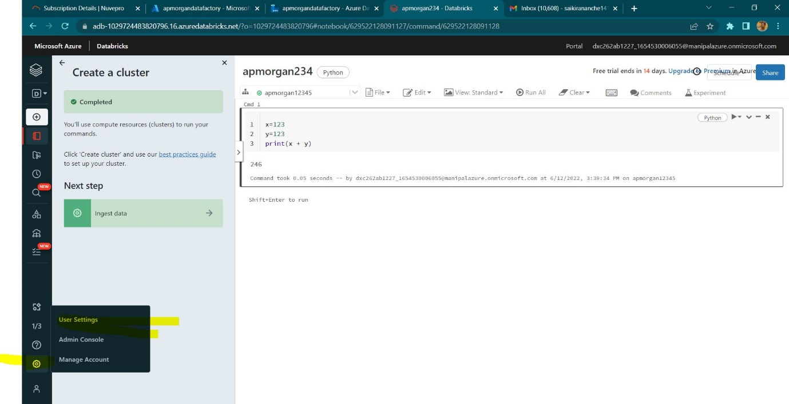

Step10: click on generate new token.

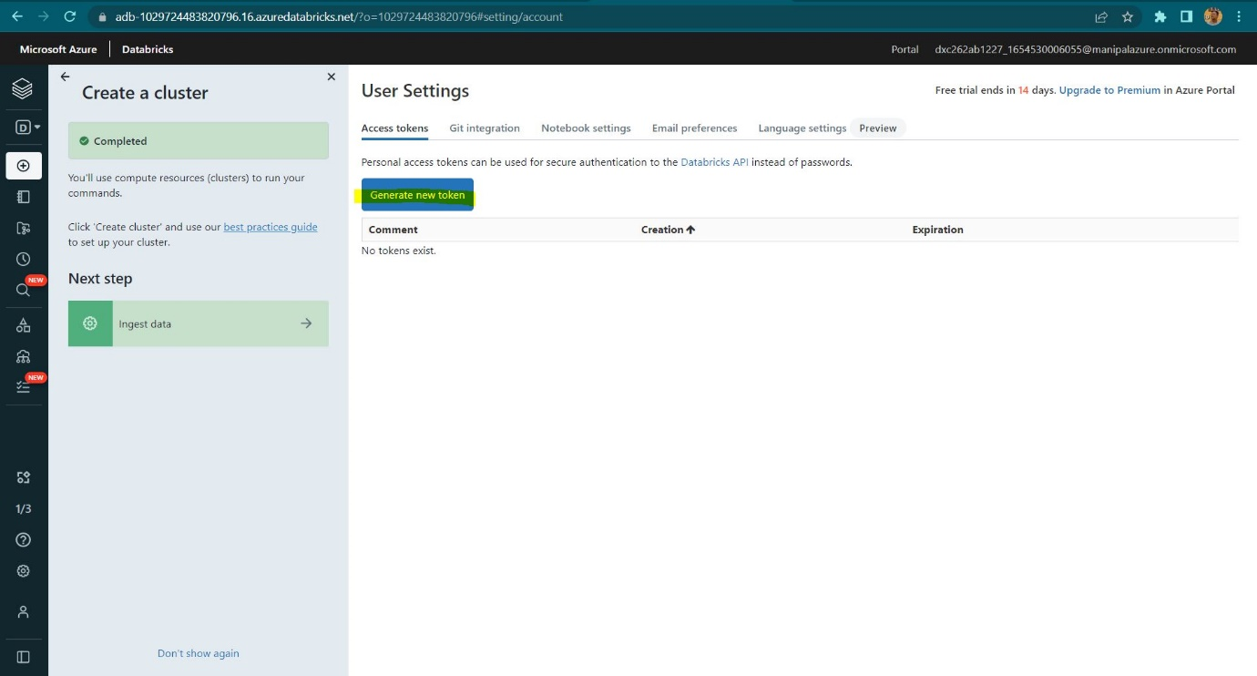

Step11: give the life time of the token and click on generate.

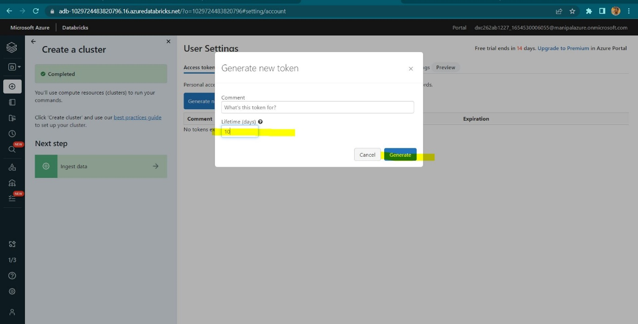

Step12: copy the generated access token.

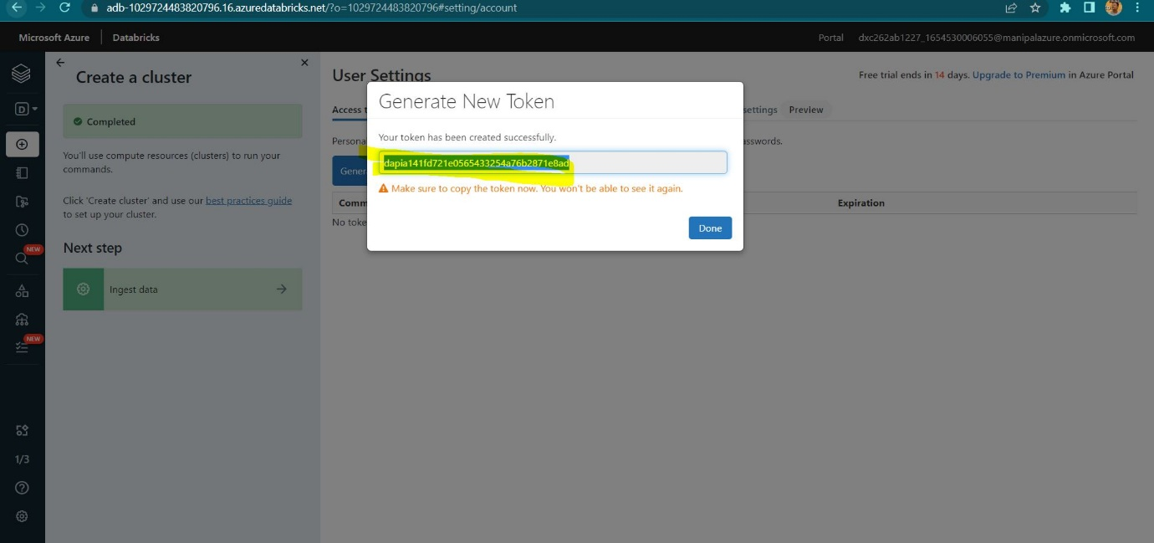

Step13: put the access token and select cluster version,cluster node type, version etc and test the connection.

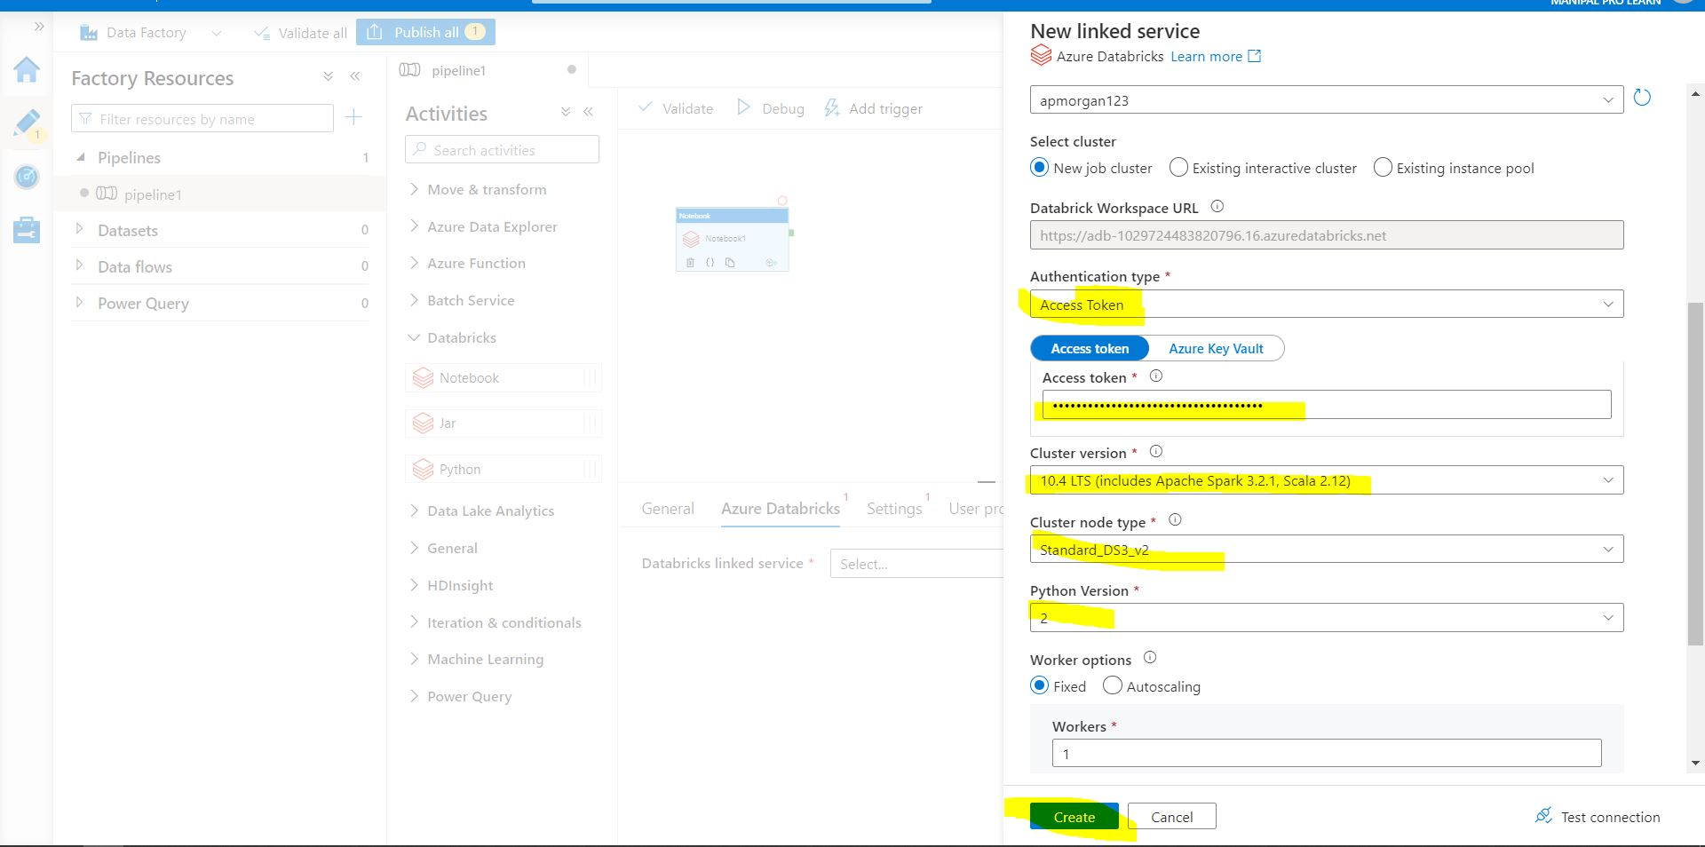

Step14: after the connection gets success click on create.

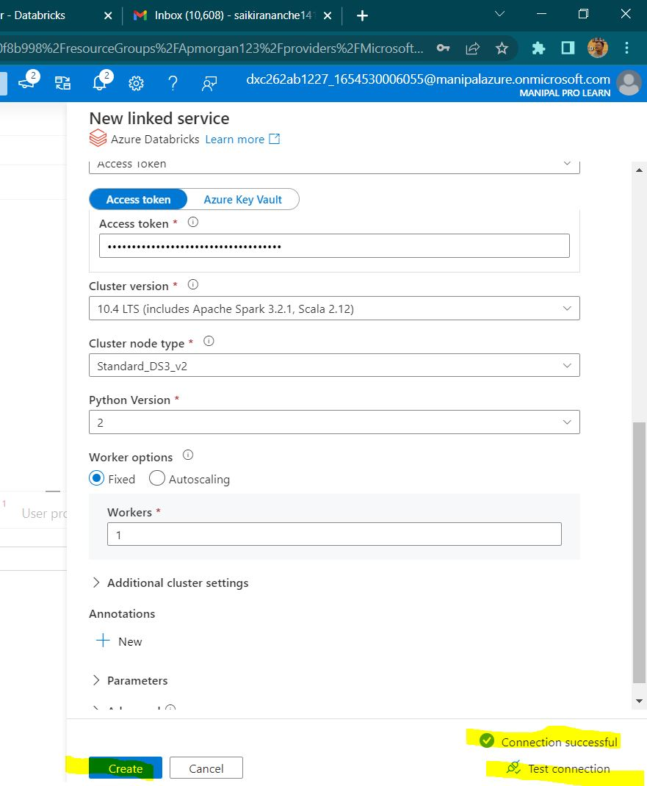

Step15: select the proper path of the notebook.

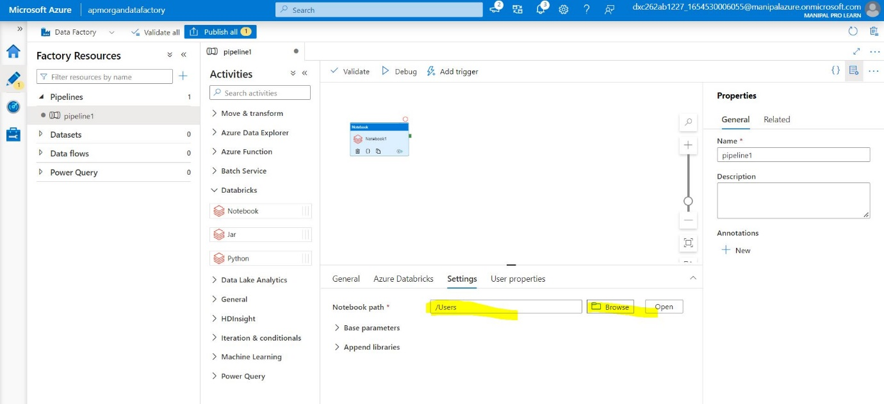

Step16: publish the pipeline in-order to save.

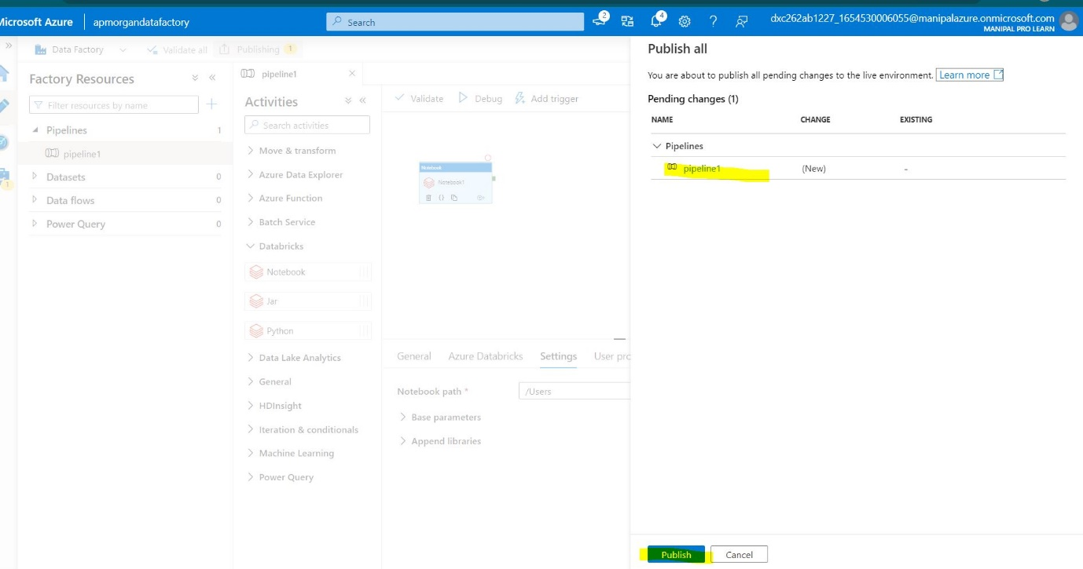

Step17: trigger the pipeline by clicking on add trigger >trigger now.

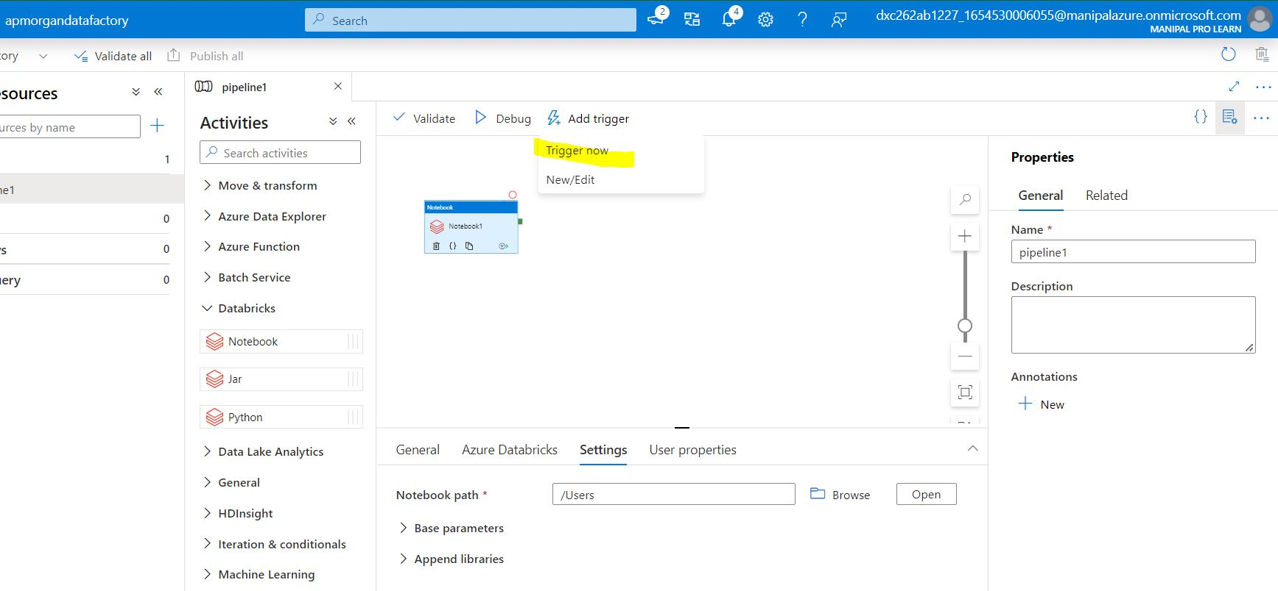

Step18: You can see the notification running.

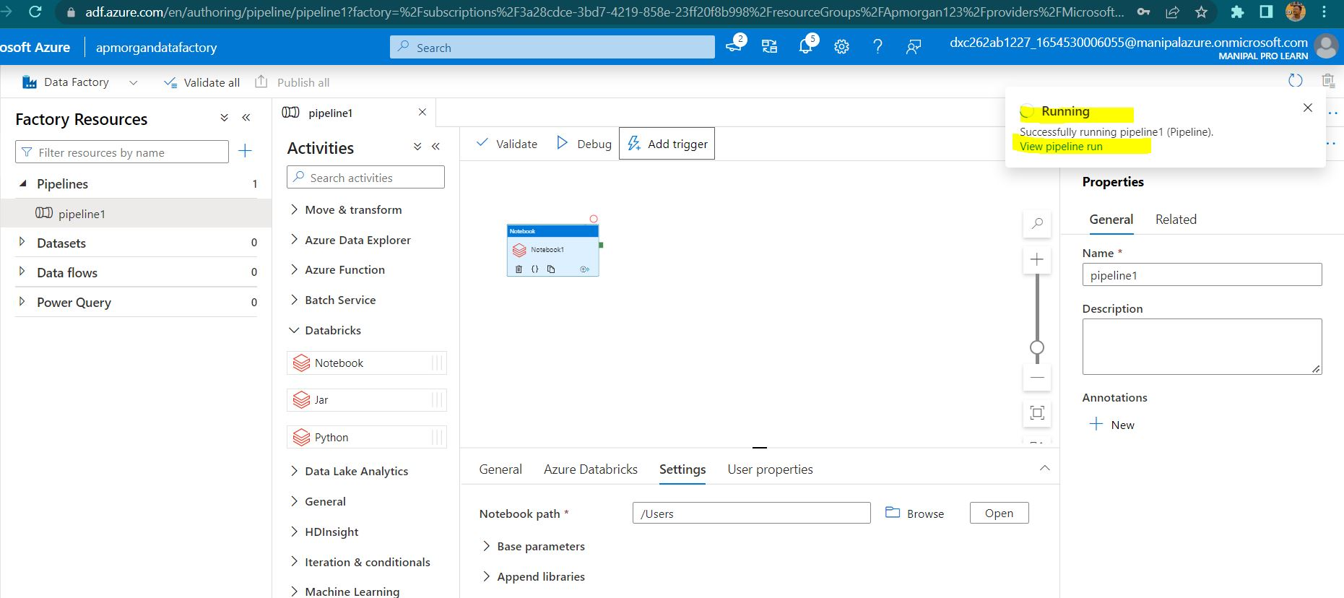

Step19: you can see your pipeline run by opting the monitor

Option in the DF and hence the azure data bricks based ADF service is created.

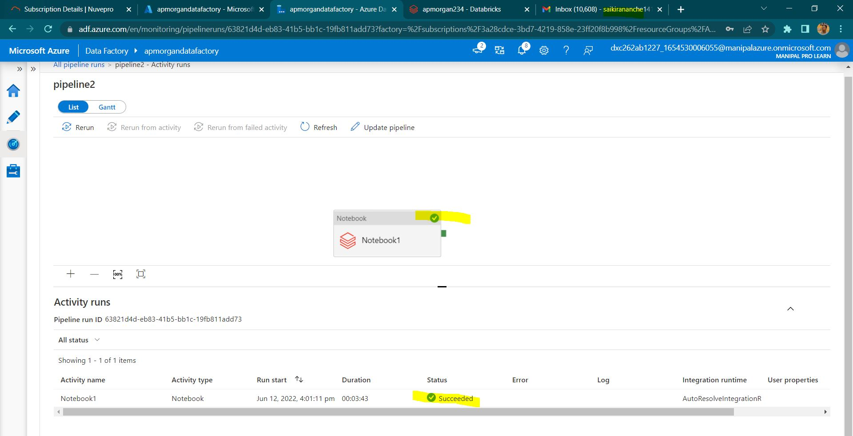

**Result:**

Most of the project requirements have been fulfilled by the step by step procedures.

**Conclusion:**

All the cases have been sloved successfully, it was so challenging when few of the pipelines got failed. After referring the error messages I’m able to run the pipelines successfully and had a great experience while learning the concepts in deep.

Apart of the demonstrations that were explained in the tutorials I’m able to perform a variety of new operations with a lot of enthusiasm and engagement in learning.